# Analysis – Descriptive Report

## Participant: Auditive score

* Good: hear left and right
* Perfect: hear left, right and front

|  |  |  |
| --- | --- | --- |
| **Statistics** | | |
| Score_Auditive_test | | |
| N | Valid | 42 |
| Missing | 0 |
| Mean | | 2,88 |
| Median | | 3,00 |
| Std. Deviation | | ,328 |
| Variance | | ,107 |
| Minimum | | 2 |
| Maximum | | 3 |
| Sum | | 121 |
| Percentiles | 25 | 3,00 |
| 50 | 3,00 |
| 75 | 3,00 |

|  |  |  |  |  |  |
| --- | --- | --- | --- | --- | --- |
| **Score_Auditive_test** | | | | | |
|  | | Frequency | Percent | Valid Percent | Cumulative Percent |
| Valid | Good | 5 | 11,9 | 11,9 | 11,9 |
| Perfect | 37 | 88,1 | 88,1 | 100,0 |
| Total | 42 | 100,0 | 100,0 |  |

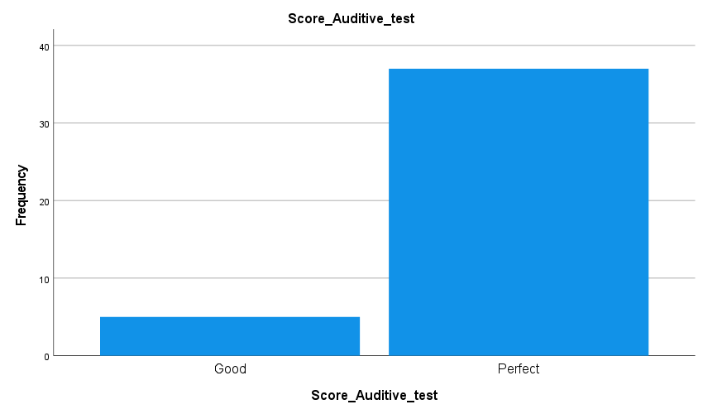

## Participant: Genre

* 0 = Undefined
* 1 = Male
* 2 = Female

|  |  |  |  |  |  |
| --- | --- | --- | --- | --- | --- |
| **Genre** | | | | | |
|  | | Frequency | Percent | Valid Percent | Cumulative Percent |
| Valid | Undefined | 4 | 9,5 | 9,5 | 9,5 |
| Male | 22 | 52,4 | 52,4 | 61,9 |
| Female | 16 | 38,1 | 38,1 | 100,0 |
| Total | 42 | 100,0 | 100,0 |  |

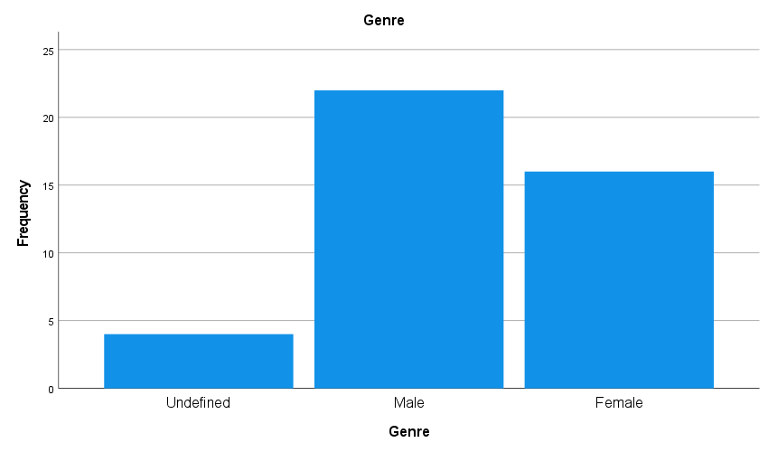

## Participant: Age

* 1 = 18-25
* 2 = 26-34

|  |  |  |  |  |  |
| --- | --- | --- | --- | --- | --- |
| **Age** | | | | | |
|  | | Frequency | Percent | Valid Percent | Cumulative Percent |
| Valid | 18-25 | 39 | 92,9 | 92,9 | 92,9 |
| 26-34 | 3 | 7,1 | 7,1 | 100,0 |
| Total | 42 | 100,0 | 100,0 |  |

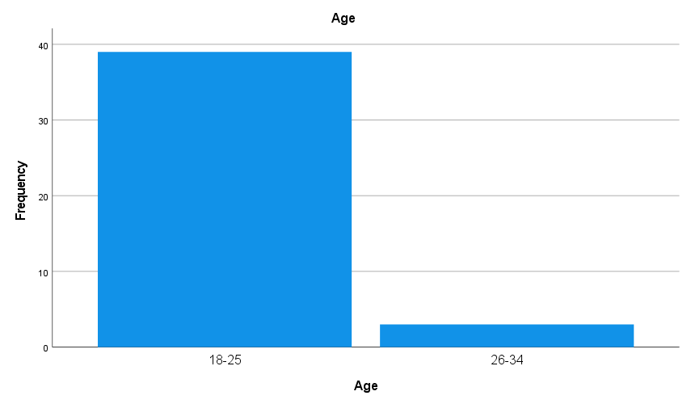

## Participant: Usage of videoconference

|  |  |  |  |  |  |
| --- | --- | --- | --- | --- | --- |
| **Videoconference_Usage** | | | | | |
|  | | Frequency | Percent | Valid Percent | Cumulative Percent |
| Valid | More than once every six months | 2 | 4,8 | 4,8 | 4,8 |
| More than once a month | 3 | 7,1 | 7,1 | 11,9 |
| More than once a week | 37 | 88,1 | 88,1 | 100,0 |
| Total | 42 | 100,0 | 100,0 |  |

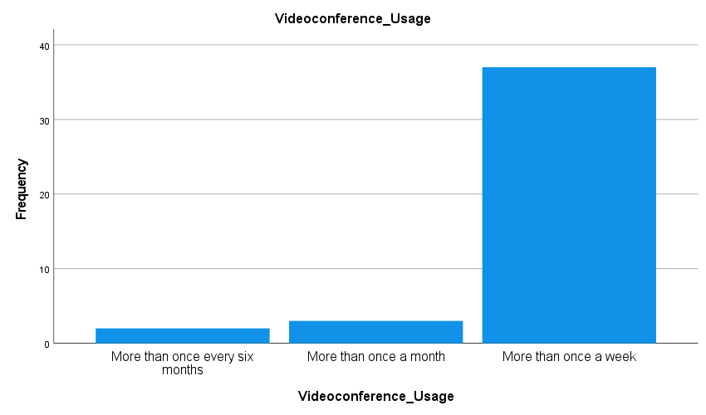

## Memory Test

6 statements to link to the correct conferee

Maximum score = 6, Minimum score = 0

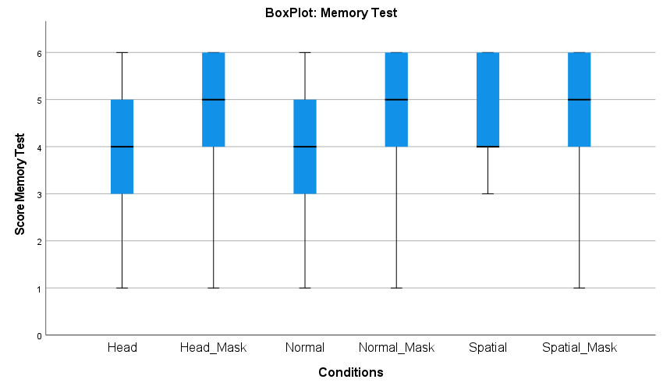

|  |  |  |  |  |  |  |  |
| --- | --- | --- | --- | --- | --- | --- | --- |
| **Statistics** | | | | | | | |
|  | | Normal | Normal_Mask | Spatial | Spatial_Mask | Head | Head_Mask |
| N | Valid | 42 | 42 | 42 | 42 | 42 | 42 |
| Missing | 0 | 0 | 0 | 0 | 0 | 0 |
| Mean | | 4,05 | 4,64 | 4,55 | 4,52 | 4,07 | 4,76 |
| Median | | 4,00 | 5,00 | 4,00 | 5,00 | 4,00 | 5,00 |
| Std. Deviation | | 1,306 | 1,428 | 1,131 | 1,348 | 1,237 | 1,411 |
| Variance | | 1,705 | 2,040 | 1,278 | 1,816 | 1,531 | 1,991 |
| Minimum | | 1 | 1 | 3 | 1 | 1 | 1 |
| Maximum | | 6 | 6 | 6 | 6 | 6 | 6 |
| Sum | | 170 | 195 | 191 | 190 | 171 | 200 |
| Percentiles | 25 | 3,00 | 4,00 | 4,00 | 3,75 | 3,00 | 4,00 |
| 50 | 4,00 | 5,00 | 4,00 | 5,00 | 4,00 | 5,00 |
| 75 | 5,00 | 6,00 | 6,00 | 6,00 | 5,00 | 6,00 |

**Frequency Table**

|  |  |  |  |  |  |
| --- | --- | --- | --- | --- | --- |
| **Normal** | | | | | |
|  | | Frequency | Percent | Valid Percent | Cumulative Percent |
| Valid | 1 | 1 | 2,4 | 2,4 | 2,4 |
| 2 | 5 | 11,9 | 11,9 | 14,3 |
| 3 | 6 | 14,3 | 14,3 | 28,6 |
| 4 | 16 | 38,1 | 38,1 | 66,7 |
| 5 | 7 | 16,7 | 16,7 | 83,3 |
| 6 | 7 | 16,7 | 16,7 | 100,0 |
| Total | 42 | 100,0 | 100,0 |  |

|  |  |  |  |  |  |
| --- | --- | --- | --- | --- | --- |
| **Normal_Mask** | | | | | |
|  | | Frequency | Percent | Valid Percent | Cumulative Percent |
| Valid | 1 | 2 | 4,8 | 4,8 | 4,8 |
| 2 | 1 | 2,4 | 2,4 | 7,1 |
| 3 | 6 | 14,3 | 14,3 | 21,4 |
| 4 | 8 | 19,0 | 19,0 | 40,5 |
| 5 | 9 | 21,4 | 21,4 | 61,9 |
| 6 | 16 | 38,1 | 38,1 | 100,0 |
| Total | 42 | 100,0 | 100,0 |  |

|  |  |  |  |  |  |
| --- | --- | --- | --- | --- | --- |
| **Spatial** | | | | | |
|  | | Frequency | Percent | Valid Percent | Cumulative Percent |
| Valid | 3 | 9 | 21,4 | 21,4 | 21,4 |
| 4 | 13 | 31,0 | 31,0 | 52,4 |
| 5 | 8 | 19,0 | 19,0 | 71,4 |
| 6 | 12 | 28,6 | 28,6 | 100,0 |
| Total | 42 | 100,0 | 100,0 |  |

|  |  |  |  |  |  |
| --- | --- | --- | --- | --- | --- |
| **Spatial_Mask** | | | | | |
|  | | Frequency | Percent | Valid Percent | Cumulative Percent |
| Valid | 1 | 1 | 2,4 | 2,4 | 2,4 |
| 2 | 2 | 4,8 | 4,8 | 7,1 |
| 3 | 7 | 16,7 | 16,7 | 23,8 |
| 4 | 9 | 21,4 | 21,4 | 45,2 |
| 5 | 10 | 23,8 | 23,8 | 69,0 |
| 6 | 13 | 31,0 | 31,0 | 100,0 |
| Total | 42 | 100,0 | 100,0 |  |

|  |  |  |  |  |  |
| --- | --- | --- | --- | --- | --- |
| **Head** | | | | | |
|  | | Frequency | Percent | Valid Percent | Cumulative Percent |
| Valid | 1 | 1 | 2,4 | 2,4 | 2,4 |
| 2 | 2 | 4,8 | 4,8 | 7,1 |
| 3 | 11 | 26,2 | 26,2 | 33,3 |
| 4 | 14 | 33,3 | 33,3 | 66,7 |
| 5 | 7 | 16,7 | 16,7 | 83,3 |
| 6 | 7 | 16,7 | 16,7 | 100,0 |
| Total | 42 | 100,0 | 100,0 |  |

|  |  |  |  |  |  |
| --- | --- | --- | --- | --- | --- |
| **Head_Mask** | | | | | |
|  | | Frequency | Percent | Valid Percent | Cumulative Percent |
| Valid | 1 | 2 | 4,8 | 4,8 | 4,8 |
| 2 | 2 | 4,8 | 4,8 | 9,5 |
| 3 | 2 | 4,8 | 4,8 | 14,3 |
| 4 | 9 | 21,4 | 21,4 | 35,7 |
| 5 | 10 | 23,8 | 23,8 | 59,5 |
| 6 | 17 | 40,5 | 40,5 | 100,0 |
| Total | 42 | 100,0 | 100,0 |  |

### Significance tests

#### No mask vs. Mask SIGNIFICANT

##### Friedman SIGNIFICANT

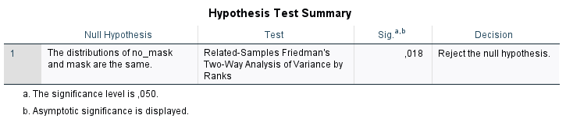

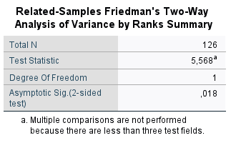

##### Wilcoxon signed rank test

|  |  |  |  |  |  |
| --- | --- | --- | --- | --- | --- |
| **Descriptive Statistics** | | | | | |
|  | N | Mean | Std. Deviation | Minimum | Maximum |
| Normal | 42 | 4,05 | 1,306 | 1 | 6 |
| Spatial | 42 | 4,55 | 1,131 | 3 | 6 |
| Head | 42 | 4,07 | 1,237 | 1 | 6 |
| Normal_Mask | 42 | 4,64 | 1,428 | 1 | 6 |
| Spatial_Mask | 42 | 4,52 | 1,348 | 1 | 6 |
| Head_Mask | 42 | 4,76 | 1,411 | 1 | 6 |

|  |  |  |  |  |
| --- | --- | --- | --- | --- |
| **Ranks** | | | | |
|  | | N | Mean Rank | Sum of Ranks |
| Normal_Mask - Normal | Negative Ranks | 12a | 15,13 | 181,50 |
| Positive Ranks | 22b | 18,80 | 413,50 |
| Ties | 8c |  |  |
| Total | 42 |  |  |
| Spatial_Mask - Spatial | Negative Ranks | 17d | 13,44 | 228,50 |
| Positive Ranks | 13e | 18,19 | 236,50 |
| Ties | 12f |  |  |
| Total | 42 |  |  |
| Head_Mask - Head | Negative Ranks | 7g | 18,86 | 132,00 |
| Positive Ranks | 24h | 15,17 | 364,00 |
| Ties | 11i |  |  |
| Total | 42 |  |  |
| a. Normal_Mask < Normal | | | | |
| b. Normal_Mask > Normal | | | | |
| c. Normal_Mask = Normal | | | | |
| d. Spatial_Mask < Spatial | | | | |
| e. Spatial_Mask > Spatial | | | | |
| f. Spatial_Mask = Spatial | | | | |
| g. Head_Mask < Head | | | | |
| h. Head_Mask > Head | | | | |
| i. Head_Mask = Head | | | | |

|  |  |  |  |
| --- | --- | --- | --- |
| **Test Statisticsa** | | | |
|  | Normal_Mask - Normal | Spatial_Mask - Spatial | Head_Mask - Head |
| Z | -2,018b | -,084b | -2,304b |
| Asymp. Sig. (2-tailed) | ,044 | ,933 | ,021 |
| a. Wilcoxon Signed Ranks Test | | | |
| b. Based on negative ranks. | | | |

**There is an interaction effect between No-Mask and Mask conditions in the memory test score. The mono and head auditive formats have a mean score higher in the visual condition with mask.**

#### No mask

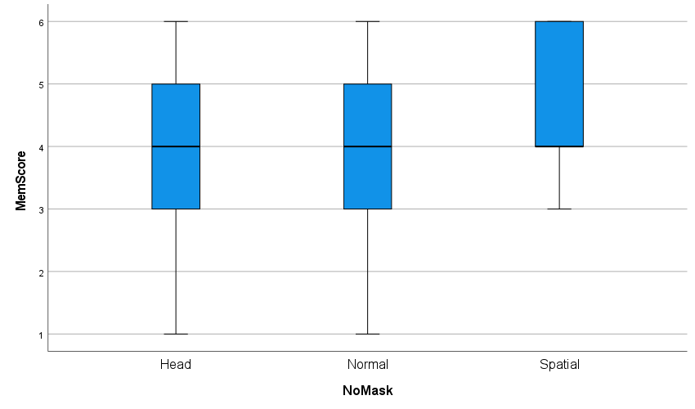

|  |  |  |  |  |  |
| --- | --- | --- | --- | --- | --- |
| **Tests of Homogeneity of Variances** | | | | | |
|  | | Levene Statistic | df1 | df2 | Sig. |
| MemScore | Based on Mean | ,051 | 2 | 123 | ,950 |
| Based on Median | ,035 | 2 | 123 | ,966 |
| Based on Median and with adjusted df | ,035 | 2 | 121,653 | ,966 |
| Based on trimmed mean | ,031 | 2 | 123 | ,970 |

Homogeneity of variances : OK

|  |  |  |  |  |  |  |  |
| --- | --- | --- | --- | --- | --- | --- | --- |
| **Tests of Normality** | | | | | | | |
|  | NoMask | Kolmogorov-Smirnova | | | Shapiro-Wilk | | |
|  | Statistic | df | Sig. | Statistic | df | Sig. |
| MemScore | Head | ,190 | 42 | ,001 | ,919 | 42 | ,006 |
| Normal | ,200 | 42 | ,000 | ,920 | 42 | ,006 |
| Spatial | ,210 | 42 | ,000 | ,851 | 42 | ,000 |
| a. Lilliefors Significance Correction | | | | | | | |

Normal distribution: Not ok => ANOVA can’t be performed.

|  |  |  |  |  |  |
| --- | --- | --- | --- | --- | --- |
| **ANOVA** | | | | | |
| MemTest | | | | | |
|  | Sum of Squares | df | Mean Square | F | Sig. |
| Between Groups | 6,683 | 2 | 3,341 | 2,220 | ,113 |
| Within Groups | 185,095 | 123 | 1,505 |  |  |
| Total | 191,778 | 125 |  |  |  |

**Kruskal-Wallis test :**

|  |  |  |  |  |
| --- | --- | --- | --- | --- |
| **Hypothesis Test Summary** | | | | |
|  | Null Hypothesis | Test | Sig.a,b | Decision |
| 1 | The distribution of MemScore is the same across categories of NoMask. | Independent-Samples Kruskal-Wallis Test | ,166 | Retain the null hypothesis. |
| a. The significance level is ,050. | | | | |
| b. Asymptotic significance is displayed. | | | | |

|  |  |
| --- | --- |
| **Independent-Samples Kruskal-Wallis Test Summary** | |
| Total N | 126 |
| Test Statistic | 3,595a,b |
| Degree Of Freedom | 2 |
| Asymptotic Sig.(2-sided test) | ,166 |
| a. The test statistic is adjusted for ties. | |
| b. Multiple comparisons are not performed because the overall test does not show significant differences across samples. | |

There is no significant difference between the conditions

##### Friedman

|  |  |  |  |  |
| --- | --- | --- | --- | --- |
| **Hypothesis Test Summary** | | | | |
|  | Null Hypothesis | Test | Sig.a,b | Decision |
| 1 | The distributions of Normal, Spatial and Head are the same. | Related-Samples Friedman's Two-Way Analysis of Variance by Ranks | ,284 | Retain the null hypothesis. |
| a. The significance level is ,050. | | | | |
| b. Asymptotic significance is displayed. | | | | |

|  |  |
| --- | --- |
| **Related-Samples Friedman's Two-Way Analysis of Variance by Ranks Summary** | |
| Total N | 42 |
| Test Statistic | 2,515a |
| Degree Of Freedom | 2 |
| Asymptotic Sig.(2-sided test) | ,284 |
| a. Multiple comparisons are not performed because the overall test retained the null hypothesis of no differences. | |

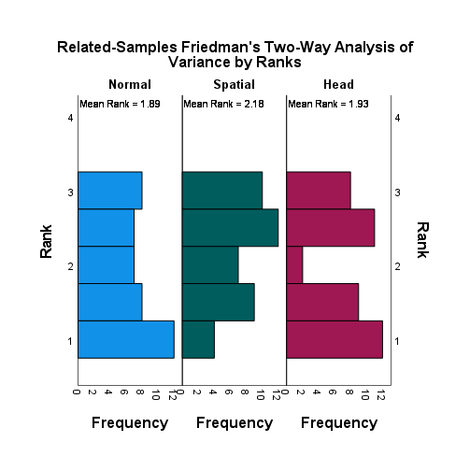

#### Mask

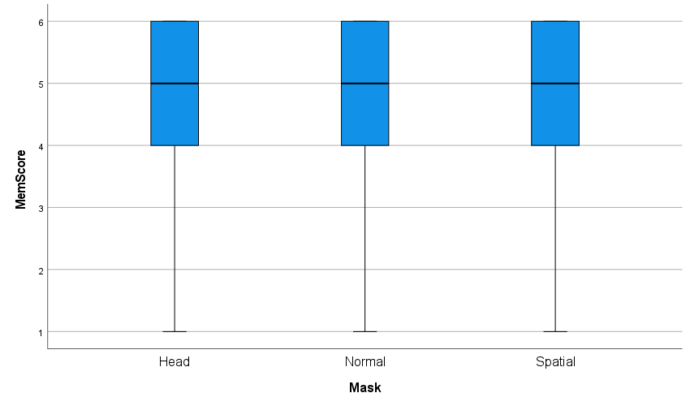

|  |  |  |  |  |  |
| --- | --- | --- | --- | --- | --- |
| **Tests of Homogeneity of Variances** | | | | | |
|  | | Levene Statistic | df1 | df2 | Sig. |
| Mask | Based on Mean | ,092 | 2 | 123 | ,912 |
| Based on Median | ,063 | 2 | 123 | ,939 |
| Based on Median and with adjusted df | ,063 | 2 | 122,701 | ,939 |
| Based on trimmed mean | ,123 | 2 | 123 | ,885 |

Homogeneity of variances : OK

|  |  |  |  |  |  |  |  |
| --- | --- | --- | --- | --- | --- | --- | --- |
| **Tests of Normality** | | | | | | | |
|  | Mask | Kolmogorov-Smirnova | | | Shapiro-Wilk | | |
|  | Statistic | df | Sig. | Statistic | df | Sig. |
| MemScore | Head | ,215 | 42 | ,000 | ,814 | 42 | ,000 |
| Normal | ,210 | 42 | ,000 | ,847 | 42 | ,000 |
| Spatial | ,186 | 42 | ,001 | ,886 | 42 | ,001 |
| a. Lilliefors Significance Correction | | | | | | | |

Normal distribution: Not ok => ANOVA can’t be performed.

|  |  |  |  |  |  |
| --- | --- | --- | --- | --- | --- |
| **ANOVA** | | | | | |
| MemTest | | | | | |
|  | Sum of Squares | df | Mean Square | F | Sig. |
| Between Groups | 1,190 | 2 | ,595 | ,305 | ,737 |
| Within Groups | 239,738 | 123 | 1,949 |  |  |
| Total | 240,929 | 125 |  |  |  |

**Kruskal-Wallis Test:**

|  |  |  |  |  |
| --- | --- | --- | --- | --- |
| **Hypothesis Test Summary** | | | | |
|  | Null Hypothesis | Test | Sig.a,b | Decision |
| 1 | The distribution of MemScore is the same across categories of Mask. | Independent-Samples Kruskal-Wallis Test | ,597 | Retain the null hypothesis. |
| a. The significance level is ,050. | | | | |
| b. Asymptotic significance is displayed. | | | | |

|  |  |
| --- | --- |
| **Independent-Samples Kruskal-Wallis Test Summary** | |
| Total N | 126 |
| Test Statistic | 1,033a,b |
| Degree Of Freedom | 2 |
| Asymptotic Sig.(2-sided test) | ,597 |
| a. The test statistic is adjusted for ties. | |
| b. Multiple comparisons are not performed because the overall test does not show significant differences across samples. | |

There is no significant difference between the conditions

##### Friedman

|  |  |  |  |  |
| --- | --- | --- | --- | --- |
| **Hypothesis Test Summary** | | | | |
|  | Null Hypothesis | Test | Sig.a,b | Decision |
| 1 | The distributions of Normal_Mask, Spatial_Mask and Head_Mask are the same. | Related-Samples Friedman's Two-Way Analysis of Variance by Ranks | ,317 | Retain the null hypothesis. |
| a. The significance level is ,050. | | | | |
| b. Asymptotic significance is displayed. | | | | |

|  |  |
| --- | --- |
| **Related-Samples Friedman's Two-Way Analysis of Variance by Ranks Summary** | |
| Total N | 42 |
| Test Statistic | 2,297a |
| Degree Of Freedom | 2 |
| Asymptotic Sig.(2-sided test) | ,317 |
| a. Multiple comparisons are not performed because the overall test retained the null hypothesis of no differences. | |

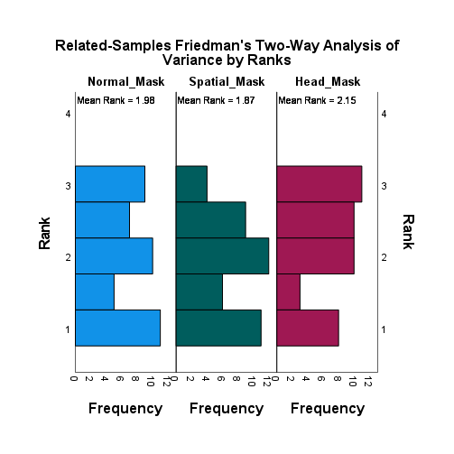

## Memory Confidence

How confident are you with your previous answer?

* 1 = Very little confidence
* 2 = Little confidence
* 3 = Neutral
* 4 = Confident
* 5 = Very confident

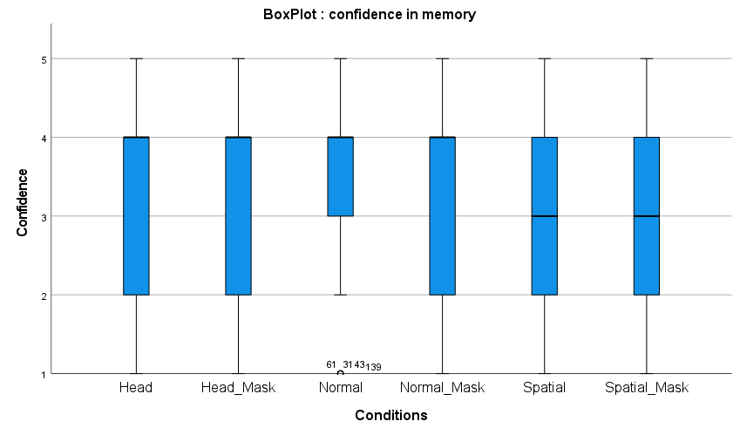

|  |  |  |  |  |  |  |  |
| --- | --- | --- | --- | --- | --- | --- | --- |
| **Statistics** | | | | | | | |
|  | | Normal | Normal_Mask | Spatial | Spatial_Mask | Head | Head_Mask |
| N | Valid | 42 | 42 | 42 | 42 | 42 | 42 |
| Missing | 0 | 0 | 0 | 0 | 0 | 0 |
| Mean | | 3,48 | 3,31 | 3,12 | 3,02 | 3,29 | 3,48 |
| Median | | 4,00 | 4,00 | 3,00 | 3,00 | 4,00 | 4,00 |
| Std. Deviation | | 1,153 | 1,158 | ,968 | 1,158 | 1,215 | 1,311 |
| Variance | | 1,329 | 1,341 | ,937 | 1,341 | 1,477 | 1,719 |
| Minimum | | 1 | 1 | 1 | 1 | 1 | 1 |
| Maximum | | 5 | 5 | 5 | 5 | 5 | 5 |
| Sum | | 146 | 139 | 131 | 127 | 138 | 146 |
| Percentiles | 25 | 3,00 | 2,00 | 2,00 | 2,00 | 2,00 | 2,00 |
| 50 | 4,00 | 4,00 | 3,00 | 3,00 | 4,00 | 4,00 |
| 75 | 4,00 | 4,00 | 4,00 | 4,00 | 4,00 | 4,25 |

**Frequency Table**

|  |  |  |  |  |  |
| --- | --- | --- | --- | --- | --- |
| **Normal** | | | | | |
|  | | Frequency | Percent | Valid Percent | Cumulative Percent |
| Valid | Very little confidence | 4 | 9,5 | 9,5 | 9,5 |
| Little confidence | 4 | 9,5 | 9,5 | 19,0 |
| Neutral | 8 | 19,0 | 19,0 | 38,1 |
| Confident | 20 | 47,6 | 47,6 | 85,7 |
| Very confident | 6 | 14,3 | 14,3 | 100,0 |
| Total | 42 | 100,0 | 100,0 |  |

|  |  |  |  |  |  |
| --- | --- | --- | --- | --- | --- |
| **Normal_Mask** | | | | | |
|  | | Frequency | Percent | Valid Percent | Cumulative Percent |
| Valid | Very little confidence | 2 | 4,8 | 4,8 | 4,8 |
| Little confidence | 11 | 26,2 | 26,2 | 31,0 |
| Neutral | 7 | 16,7 | 16,7 | 47,6 |
| Confident | 16 | 38,1 | 38,1 | 85,7 |
| Very confident | 6 | 14,3 | 14,3 | 100,0 |
| Total | 42 | 100,0 | 100,0 |  |

|  |  |  |  |  |  |
| --- | --- | --- | --- | --- | --- |
| **Spatial** | | | | | |
|  | | Frequency | Percent | Valid Percent | Cumulative Percent |
| Valid | Very little confidence | 2 | 4,8 | 4,8 | 4,8 |
| Little confidence | 9 | 21,4 | 21,4 | 26,2 |
| Neutral | 15 | 35,7 | 35,7 | 61,9 |
| Confident | 14 | 33,3 | 33,3 | 95,2 |
| Very confident | 2 | 4,8 | 4,8 | 100,0 |
| Total | 42 | 100,0 | 100,0 |  |

|  |  |  |  |  |  |
| --- | --- | --- | --- | --- | --- |
| **Spatial_Mask** | | | | | |
|  | | Frequency | Percent | Valid Percent | Cumulative Percent |
| Valid | Very little confidence | 3 | 7,1 | 7,1 | 7,1 |
| Little confidence | 14 | 33,3 | 33,3 | 40,5 |
| Neutral | 8 | 19,0 | 19,0 | 59,5 |
| Confident | 13 | 31,0 | 31,0 | 90,5 |
| Very confident | 4 | 9,5 | 9,5 | 100,0 |
| Total | 42 | 100,0 | 100,0 |  |

|  |  |  |  |  |  |
| --- | --- | --- | --- | --- | --- |
| **Head** | | | | | |
|  | | Frequency | Percent | Valid Percent | Cumulative Percent |
| Valid | Very little confidence | 4 | 9,5 | 9,5 | 9,5 |
| Little confidence | 8 | 19,0 | 19,0 | 28,6 |
| Neutral | 8 | 19,0 | 19,0 | 47,6 |
| Confident | 16 | 38,1 | 38,1 | 85,7 |
| Very confident | 6 | 14,3 | 14,3 | 100,0 |
| Total | 42 | 100,0 | 100,0 |  |

|  |  |  |  |  |  |
| --- | --- | --- | --- | --- | --- |
| **Head_Mask** | | | | | |
|  | | Frequency | Percent | Valid Percent | Cumulative Percent |
| Valid | Very little confidence | 4 | 9,5 | 9,5 | 9,5 |
| Little confidence | 8 | 19,0 | 19,0 | 28,6 |
| Neutral | 4 | 9,5 | 9,5 | 38,1 |
| Confident | 16 | 38,1 | 38,1 | 76,2 |
| Very confident | 10 | 23,8 | 23,8 | 100,0 |
| Total | 42 | 100,0 | 100,0 |  |

### Significance tests

#### No mask vs. Mask

##### Friedman

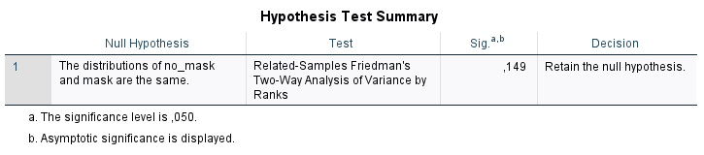

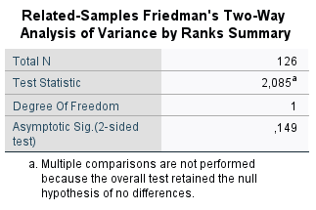

There is no interaction effect between mask and no mask.

#### No mask

|  |  |  |  |  |  |
| --- | --- | --- | --- | --- | --- |
| **Levene's Test of Equality of Error Variancesa,b** | | | | | |
|  | | Levene Statistic | df1 | df2 | Sig. |
| MemConf | Based on Mean | 2,001 | 2 | 123 | ,140 |
| Based on Median | 1,001 | 2 | 123 | ,370 |
| Based on Median and with adjusted df | 1,001 | 2 | 109,836 | ,371 |
| Based on trimmed mean | 1,864 | 2 | 123 | ,159 |
| Tests the null hypothesis that the error variance of the dependent variable is equal across groups. | | | | | |
| a. Dependent variable: MemConf | | | | | |
| b. Design: Intercept + NoMask | | | | | |

Homogeneous variances : OK.

|  |  |  |  |  |  |  |  |
| --- | --- | --- | --- | --- | --- | --- | --- |
| **Tests of Normality** | | | | | | | |
|  | NoMask | Kolmogorov-Smirnova | | | Shapiro-Wilk | | |
|  | Statistic | df | Sig. | Statistic | df | Sig. |
| MemConf | Head | ,245 | 42 | ,000 | ,892 | 42 | ,001 |
| Normal | ,294 | 42 | ,000 | ,849 | 42 | ,000 |
| Spatial | ,200 | 42 | ,000 | ,901 | 42 | ,002 |
| a. Lilliefors Significance Correction | | | | | | | |

No normal distribution => ANOVA can’t be performed.

|  |  |  |  |  |  |
| --- | --- | --- | --- | --- | --- |
| **ANOVA** | | | | | |
| MemConf | | | | | |
|  | Sum of Squares | df | Mean Square | F | Sig. |
| Between Groups | 2,683 | 2 | 1,341 | 1,075 | ,344 |
| Within Groups | 153,452 | 123 | 1,248 |  |  |
| Total | 156,135 | 125 |  |  |  |

Kruskal-Wallis Test:

|  |  |  |  |  |
| --- | --- | --- | --- | --- |
| **Hypothesis Test Summary** | | | | |
|  | Null Hypothesis | Test | Sig.a,b | Decision |
| 1 | The distribution of MemConf is the same across categories of NoMask. | Independent-Samples Kruskal-Wallis Test | ,193 | Retain the null hypothesis. |
| a. The significance level is ,050. | | | | |
| b. Asymptotic significance is displayed. | | | | |

|  |  |
| --- | --- |
| **Independent-Samples Kruskal-Wallis Test Summary** | |
| Total N | 126 |
| Test Statistic | 3,285a,b |
| Degree Of Freedom | 2 |
| Asymptotic Sig.(2-sided test) | ,193 |
| a. The test statistic is adjusted for ties. | |
| b. Multiple comparisons are not performed because the overall test does not show significant differences across samples. | |

No significant difference.

##### Friedman

|  |  |  |  |  |
| --- | --- | --- | --- | --- |
| **Hypothesis Test Summary** | | | | |
|  | Null Hypothesis | Test | Sig.a,b | Decision |
| 1 | The distributions of Normal, Spatial and Head are the same. | Related-Samples Friedman's Two-Way Analysis of Variance by Ranks | ,332 | Retain the null hypothesis. |
| a. The significance level is ,050. | | | | |
| b. Asymptotic significance is displayed. | | | | |

|  |  |
| --- | --- |
| **Related-Samples Friedman's Two-Way Analysis of Variance by Ranks Summary** | |
| Total N | 42 |
| Test Statistic | 2,204a |
| Degree Of Freedom | 2 |
| Asymptotic Sig.(2-sided test) | ,332 |
| a. Multiple comparisons are not performed because the overall test retained the null hypothesis of no differences. | |

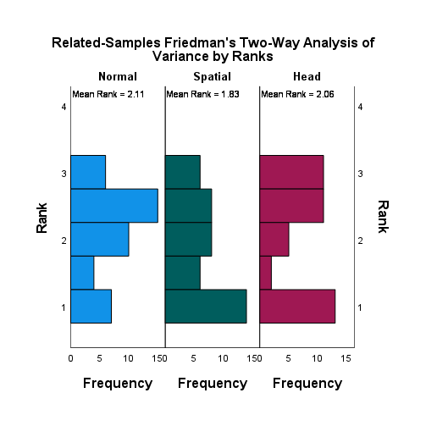

#### Mask

|  |  |  |  |  |  |
| --- | --- | --- | --- | --- | --- |
| **Levene's Test of Equality of Error Variancesa,b** | | | | | |
|  | | Levene Statistic | df1 | df2 | Sig. |
| MemConf | Based on Mean | ,681 | 2 | 123 | ,508 |
| Based on Median | ,011 | 2 | 123 | ,989 |
| Based on Median and with adjusted df | ,011 | 2 | 108,855 | ,989 |
| Based on trimmed mean | ,543 | 2 | 123 | ,582 |
| Tests the null hypothesis that the error variance of the dependent variable is equal across groups. | | | | | |
| a. Dependent variable: MemConf | | | | | |
| b. Design: Intercept + Mask | | | | | |

Homogeneous variances : OK.

|  |  |  |  |  |  |  |  |
| --- | --- | --- | --- | --- | --- | --- | --- |
| **Tests of Normality** | | | | | | | |
|  | Mask | Kolmogorov-Smirnova | | | Shapiro-Wilk | | |
|  | Statistic | df | Sig. | Statistic | df | Sig. |
| MemConf | Head | ,274 | 42 | ,000 | ,860 | 42 | ,000 |
| Normal | ,248 | 42 | ,000 | ,887 | 42 | ,001 |
| Spatial | ,216 | 42 | ,000 | ,895 | 42 | ,001 |
| a. Lilliefors Significance Correction | | | | | | | |

No normal distribution => ANOVA can’t be performed.

|  |  |  |  |  |  |
| --- | --- | --- | --- | --- | --- |
| **ANOVA** | | | | | |
| MemConf | | | | | |
|  | Sum of Squares | df | Mean Square | F | Sig. |
| Between Groups | 4,397 | 2 | 2,198 | 1,499 | ,227 |
| Within Groups | 180,429 | 123 | 1,467 |  |  |
| Total | 184,825 | 125 |  |  |  |

Kruskal-Wallis Test:

|  |  |  |  |  |
| --- | --- | --- | --- | --- |
| **Hypothesis Test Summary** | | | | |
|  | Null Hypothesis | Test | Sig.a,b | Decision |
| 1 | The distribution of MemConf is the same across categories of Mask. | Independent-Samples Kruskal-Wallis Test | ,182 | Retain the null hypothesis. |
| a. The significance level is ,050. | | | | |
| b. Asymptotic significance is displayed. | | | | |

|  |  |
| --- | --- |
| **Independent-Samples Kruskal-Wallis Test Summary** | |
| Total N | 126 |
| Test Statistic | 3,406a,b |
| Degree Of Freedom | 2 |
| Asymptotic Sig.(2-sided test) | ,182 |
| a. The test statistic is adjusted for ties. | |
| b. Multiple comparisons are not performed because the overall test does not show significant differences across samples. | |

**No significant difference.**

##### Friedman

|  |  |  |  |  |
| --- | --- | --- | --- | --- |
| **Hypothesis Test Summary** | | | | |
|  | Null Hypothesis | Test | Sig.a,b | Decision |
| 1 | The distributions of Normal_Mask, Spatial_Mask and Head_Mask are the same. | Related-Samples Friedman's Two-Way Analysis of Variance by Ranks | ,042 | Reject the null hypothesis. |
| a. The significance level is ,050. | | | | |
| b. Asymptotic significance is displayed. | | | | |

|  |  |
| --- | --- |
| **Related-Samples Friedman's Two-Way Analysis of Variance by Ranks Summary** | |
| Total N | 42 |
| Test Statistic | 6,346 |
| Degree Of Freedom | 2 |
| Asymptotic Sig.(2-sided test) | ,042 |

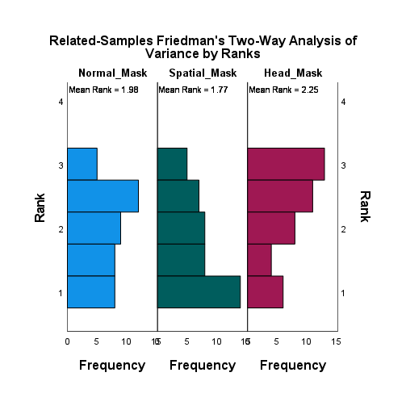

|  |  |  |  |  |  |
| --- | --- | --- | --- | --- | --- |
| **Pairwise Comparisons** | | | | | |
| Sample 1-Sample 2 | Test Statistic | Std. Error | Std. Test Statistic | Sig. | Adj. Sig.a |
| Spatial_Mask-Normal_Mask | ,202 | ,218 | ,927 | ,354 | 1,000 |
| Spatial_Mask-Head_Mask | -,476 | ,218 | -2,182 | ,029 | ,087 |
| Normal_Mask-Head_Mask | -,274 | ,218 | -1,255 | ,210 | ,629 |
| Each row tests the null hypothesis that the Sample 1 and Sample 2 distributions are the same.  Asymptotic significances (2-sided tests) are displayed. The significance level is ,050. | | | | | |
| a. Significance values have been adjusted by the Bonferroni correction for multiple tests. | | | | | |

|  |  |  |  |  |
| --- | --- | --- | --- | --- |
| **Ranks** | | | | |
|  | | N | Mean Rank | Sum of Ranks |
| Spatial_Mask - Normal_Mask | Negative Ranks | 16a | 15,88 | 254,00 |
| Positive Ranks | 12b | 12,67 | 152,00 |
| Ties | 14c |  |  |
| Total | 42 |  |  |
| Head_Mask - Normal_Mask | Negative Ranks | 11d | 15,73 | 173,00 |
| Positive Ranks | 17e | 13,71 | 233,00 |
| Ties | 14f |  |  |
| Total | 42 |  |  |
| Head_Mask - Spatial_Mask | Negative Ranks | 9g | 20,94 | 188,50 |
| Positive Ranks | 24h | 15,52 | 372,50 |
| Ties | 9i |  |  |
| Total | 42 |  |  |
| a. Spatial_Mask < Normal_Mask | | | | |
| b. Spatial_Mask > Normal_Mask | | | | |
| c. Spatial_Mask = Normal_Mask | | | | |
| d. Head_Mask < Normal_Mask | | | | |
| e. Head_Mask > Normal_Mask | | | | |
| f. Head_Mask = Normal_Mask | | | | |
| g. Head_Mask < Spatial_Mask | | | | |
| h. Head_Mask > Spatial_Mask | | | | |
| i. Head_Mask = Spatial_Mask | | | | |

|  |  |  |  |
| --- | --- | --- | --- |
| **Test Statisticsa** | | | |
|  | Spatial_Mask - Normal_Mask | Head_Mask - Normal_Mask | Head_Mask - Spatial_Mask |
| Z | -1,180b | -,699c | -1,674c |
| Asymp. Sig. (2-tailed) | ,238 | ,485 | ,094 |
| a. Wilcoxon Signed Ranks Test | | | |
| b. Based on positive ranks. | | | |
| c. Based on negative ranks. | | | |

## Comprehension Test

3 multiple choice questions on the content of the videos for each condition. Maximum score = 3, Minimum score = 0

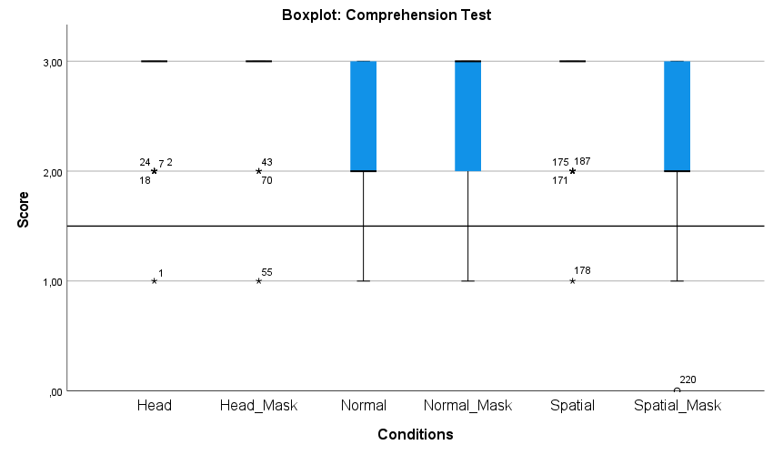

**Frequencies**

|  |  |  |  |  |  |  |  |
| --- | --- | --- | --- | --- | --- | --- | --- |
| **Statistics** | | | | | | | |
|  | | Normal | Normal_Mask | Spatial | Spatial_Mask | Head | Head_Mask |
| N | Valid | 42 | 42 | 42 | 42 | 42 | 42 |
| Missing | 0 | 0 | 0 | 0 | 0 | 0 |
| Mean | | 2,26 | 2,43 | 2,79 | 2,19 | 2,81 | 2,90 |
| Median | | 2,00 | 3,00 | 3,00 | 2,00 | 3,00 | 3,00 |
| Std. Deviation | | ,627 | ,703 | ,470 | ,773 | ,455 | ,370 |
| Variance | | ,393 | ,495 | ,221 | ,597 | ,207 | ,137 |
| Minimum | | 1 | 1 | 1 | 0 | 1 | 1 |
| Maximum | | 3 | 3 | 3 | 3 | 3 | 3 |
| Sum | | 95 | 102 | 117 | 92 | 118 | 122 |
| Percentiles | 25 | 2,00 | 2,00 | 3,00 | 2,00 | 3,00 | 3,00 |
| 50 | 2,00 | 3,00 | 3,00 | 2,00 | 3,00 | 3,00 |
| 75 | 3,00 | 3,00 | 3,00 | 3,00 | 3,00 | 3,00 |

**Frequency Table**

|  |  |  |  |  |  |
| --- | --- | --- | --- | --- | --- |
| **Normal** | | | | | |
|  | | Frequency | Percent | Valid Percent | Cumulative Percent |
| Valid | 1 | 4 | 9,5 | 9,5 | 9,5 |
| 2 | 23 | 54,8 | 54,8 | 64,3 |
| 3 | 15 | 35,7 | 35,7 | 100,0 |
| Total | 42 | 100,0 | 100,0 |  |

|  |  |  |  |  |  |
| --- | --- | --- | --- | --- | --- |
| **Normal_Mask** | | | | | |
|  | | Frequency | Percent | Valid Percent | Cumulative Percent |
| Valid | 1 | 5 | 11,9 | 11,9 | 11,9 |
| 2 | 14 | 33,3 | 33,3 | 45,2 |
| 3 | 23 | 54,8 | 54,8 | 100,0 |
| Total | 42 | 100,0 | 100,0 |  |

|  |  |  |  |  |  |
| --- | --- | --- | --- | --- | --- |
| **Spatial** | | | | | |
|  | | Frequency | Percent | Valid Percent | Cumulative Percent |
| Valid | 1 | 1 | 2,4 | 2,4 | 2,4 |
| 2 | 7 | 16,7 | 16,7 | 19,0 |
| 3 | 34 | 81,0 | 81,0 | 100,0 |
| Total | 42 | 100,0 | 100,0 |  |

|  |  |  |  |  |  |
| --- | --- | --- | --- | --- | --- |
| **Spatial_Mask** | | | | | |
|  | | Frequency | Percent | Valid Percent | Cumulative Percent |
| Valid | 0 | 1 | 2,4 | 2,4 | 2,4 |
| 1 | 6 | 14,3 | 14,3 | 16,7 |
| 2 | 19 | 45,2 | 45,2 | 61,9 |
| 3 | 16 | 38,1 | 38,1 | 100,0 |
| Total | 42 | 100,0 | 100,0 |  |

|  |  |  |  |  |  |
| --- | --- | --- | --- | --- | --- |
| **Head** | | | | | |
|  | | Frequency | Percent | Valid Percent | Cumulative Percent |
| Valid | 1 | 1 | 2,4 | 2,4 | 2,4 |
| 2 | 6 | 14,3 | 14,3 | 16,7 |
| 3 | 35 | 83,3 | 83,3 | 100,0 |
| Total | 42 | 100,0 | 100,0 |  |

|  |  |  |  |  |  |
| --- | --- | --- | --- | --- | --- |
| **Head_Mask** | | | | | |
|  | | Frequency | Percent | Valid Percent | Cumulative Percent |
| Valid | 1 | 1 | 2,4 | 2,4 | 2,4 |
| 2 | 2 | 4,8 | 4,8 | 7,1 |
| 3 | 39 | 92,9 | 92,9 | 100,0 |
| Total | 42 | 100,0 | 100,0 |  |

### Significance tests

#### No mask vs. Mask

##### Friedman

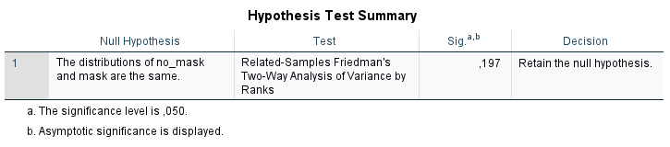

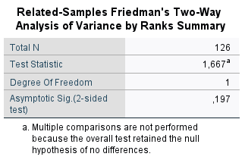

#### No mask

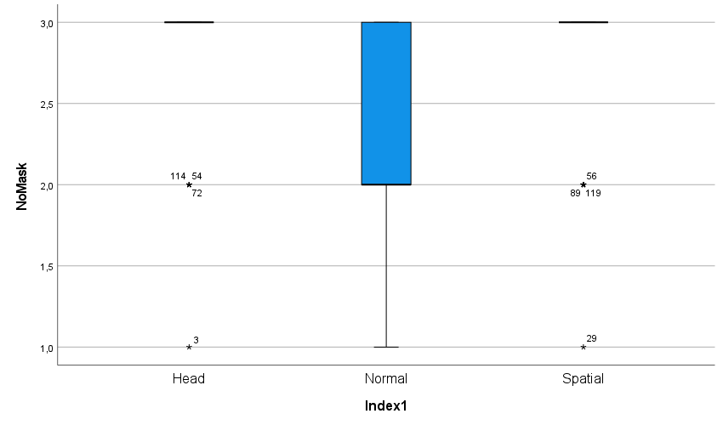

|  |  |  |  |  |  |
| --- | --- | --- | --- | --- | --- |
| **Tests of Homogeneity of Variances** | | | | | |
|  | | Levene Statistic | df1 | df2 | Sig. |
| CompScore | Based on Mean | 5,243 | 2 | 123 | ,007 |
| Based on Median | 3,876 | 2 | 123 | ,023 |
| Based on Median and with adjusted df | 3,876 | 2 | 122,086 | ,023 |
| Based on trimmed mean | 6,953 | 2 | 123 | ,001 |

Homogeneity of variances: null hypothesis: variances not homogeneous. ANOVA can’t be performed.

|  |  |  |  |  |  |  |  |
| --- | --- | --- | --- | --- | --- | --- | --- |
| **Tests of Normality** | | | | | | | |
|  | NoMask | Kolmogorov-Smirnova | | | Shapiro-Wilk | | |
|  | Statistic | df | Sig. | Statistic | df | Sig. |
| CompScore | Head | ,496 | 42 | ,000 | ,469 | 42 | ,000 |
| Normal | ,305 | 42 | ,000 | ,769 | 42 | ,000 |
| Spatial | ,485 | 42 | ,000 | ,503 | 42 | ,000 |
| a. Lilliefors Significance Correction | | | | | | | |

Null hypothesis: Not normally distributed. ANOVA can’t be performed.

There are outliers. ANOVA can’t be performed.

|  |  |  |  |  |  |
| --- | --- | --- | --- | --- | --- |
| **ANOVA** | | | | | |
| CompTest | | | | | |
|  | Sum of Squares | df | Mean Square | F | Sig. |
| Between Groups | 8,048 | 2 | 4,024 | 14,701 | ,000 |
| Within Groups | 33,667 | 123 | ,274 |  |  |
| Total | 41,714 | 125 |  |  |  |

So: Non-parametric test with Kruskal Wallis Test

|  |  |  |  |  |
| --- | --- | --- | --- | --- |
| **Hypothesis Test Summary** | | | | |
|  | Null Hypothesis | Test | Sig.a,b | Decision |
| 1 | The distribution of CompScore is the same across categories of NoMask. | Independent-Samples Kruskal-Wallis Test | ,000 | Reject the null hypothesis. |
| a. The significance level is ,050. | | | | |
| b. Asymptotic significance is displayed. | | | | |

|  |  |
| --- | --- |
| **Independent-Samples Kruskal-Wallis Test Summary** | |
| Total N | 126 |
| Test Statistic | 26,647a |
| Degree Of Freedom | 2 |
| Asymptotic Sig.(2-sided test) | ,000 |
| a. The test statistic is adjusted for ties. | |

|  |  |  |  |  |  |
| --- | --- | --- | --- | --- | --- |
| **Pairwise Comparisons of Conditions** | | | | | |
| Sample 1-Sample 2 | Test Statistic | Std. Error | Std. Test Statistic | Sig. | Adj. Sig.a |
| Normal-Spatial | -28,643 | 6,573 | -4,358 | ,000 | ,000 |
| Normal-Head | 30,071 | 6,573 | 4,575 | ,000 | ,000 |
| Spatial-Head | 1,429 | 6,573 | ,217 | ,828 | 1,000 |
| Each row tests the null hypothesis that the Sample 1 and Sample 2 distributions are the same.  Asymptotic significances (2-sided tests) are displayed. The significance level is ,050. | | | | | |
| a. Significance values have been adjusted by the Bonferroni correction for multiple tests. | | | | | |

**There is a statistical difference between Normal and Spatial, and Normal and Head for the comprehension test. We can say that Spatial and Head conditions have higher scores to the comprehension test than the Normal condition (without mask).**

##### Friedman SIGNIFICANT

|  |  |  |  |  |
| --- | --- | --- | --- | --- |
| **Hypothesis Test Summary** | | | | |
|  | Null Hypothesis | Test | Sig.a,b | Decision |
| 1 | The distributions of Normal, Spatial and Head are the same. | Related-Samples Friedman's Two-Way Analysis of Variance by Ranks | ,000 | Reject the null hypothesis. |
| a. The significance level is ,050. | | | | |
| b. Asymptotic significance is displayed. | | | | |

|  |  |
| --- | --- |
| **Related-Samples Friedman's Two-Way Analysis of Variance by Ranks Summary** | |
| Total N | 42 |
| Test Statistic | 23,128 |
| Degree Of Freedom | 2 |
| Asymptotic Sig.(2-sided test) | ,000 |

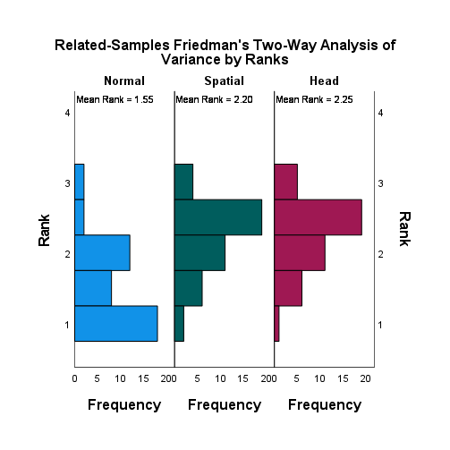

|  |  |  |  |  |  |
| --- | --- | --- | --- | --- | --- |
| **Pairwise Comparisons** | | | | | |
| Sample 1-Sample 2 | Test Statistic | Std. Error | Std. Test Statistic | Sig. | Adj. Sig.a |
| Normal-Spatial | -,655 | ,218 | -3,000 | ,003 | ,008 |
| Normal-Head | -,702 | ,218 | -3,219 | ,001 | ,004 |
| Spatial-Head | -,048 | ,218 | -,218 | ,827 | 1,000 |
| Each row tests the null hypothesis that the Sample 1 and Sample 2 distributions are the same.  Asymptotic significances (2-sided tests) are displayed. The significance level is ,050. | | | | | |
| a. Significance values have been adjusted by the Bonferroni correction for multiple tests. | | | | | |

|  |  |  |  |  |
| --- | --- | --- | --- | --- |
| **Ranks** | | | | |
|  | | N | Mean Rank | Sum of Ranks |
| Spatial - Normal | Negative Ranks | 4a | 11,50 | 46,00 |
| Positive Ranks | 22b | 13,86 | 305,00 |
| Ties | 16c |  |  |
| Total | 42 |  |  |
| a. Spatial < Normal | | | | |
| b. Spatial > Normal | | | | |
| c. Spatial = Normal | | | | |

|  |  |
| --- | --- |
| **Test Statisticsa** | |
|  | Spatial - Normal |
| Z | -3,554b |
| Asymp. Sig. (2-tailed) | ,000 |
| a. Wilcoxon Signed Ranks Test | |
| b. Based on negative ranks. | |

|  |  |  |  |  |
| --- | --- | --- | --- | --- |
| **Ranks** | | | | |
|  | | N | Mean Rank | Sum of Ranks |
| Head - Normal | Negative Ranks | 3a | 15,33 | 46,00 |
| Positive Ranks | 23b | 13,26 | 305,00 |
| Ties | 16c |  |  |
| Total | 42 |  |  |
| a. Head < Normal | | | | |
| b. Head > Normal | | | | |
| c. Head = Normal | | | | |

|  |  |
| --- | --- |
| **Test Statisticsa** | |
|  | Head - Normal |
| Z | -3,518b |
| Asymp. Sig. (2-tailed) | ,000 |
| a. Wilcoxon Signed Ranks Test | |
| b. Based on negative ranks. | |

|  |  |  |  |  |
| --- | --- | --- | --- | --- |
| **Ranks** | | | | |
|  | | N | Mean Rank | Sum of Ranks |
| Head - Spatial | Negative Ranks | 5a | 6,10 | 30,50 |
| Positive Ranks | 6b | 5,92 | 35,50 |
| Ties | 31c |  |  |
| Total | 42 |  |  |
| a. Head < Spatial | | | | |
| b. Head > Spatial | | | | |
| c. Head = Spatial | | | | |

|  |  |
| --- | --- |
| **Test Statisticsa** | |
|  | Head - Spatial |
| Z | -,237b |
| Asymp. Sig. (2-tailed) | ,813 |
| a. Wilcoxon Signed Ranks Test | |
| b. Based on negative ranks. | |

#### Mask

|  |  |  |  |  |  |  |  |
| --- | --- | --- | --- | --- | --- | --- | --- |
| **Tests of Normality** | | | | | | | |
|  | Mask | Kolmogorov-Smirnova | | | Shapiro-Wilk | | |
|  | Statistic | df | Sig. | Statistic | df | Sig. |
| CompScore | Head | ,530 | 42 | ,000 | ,283 | 42 | ,000 |
| Normal | ,339 | 42 | ,000 | ,735 | 42 | ,000 |
| Spatial | ,236 | 42 | ,000 | ,814 | 42 | ,000 |
| a. Lilliefors Significance Correction | | | | | | | |

|  |  |  |  |  |  |
| --- | --- | --- | --- | --- | --- |
| **Levene's Test of Equality of Error Variancesa,b** | | | | | |
|  | | Levene Statistic | df1 | df2 | Sig. |
| CompScore | Based on Mean | 20,450 | 2 | 123 | ,000 |
| Based on Median | 10,224 | 2 | 123 | ,000 |
| Based on Median and with adjusted df | 10,224 | 2 | 100,668 | ,000 |
| Based on trimmed mean | 25,591 | 2 | 123 | ,000 |
| Tests the null hypothesis that the error variance of the dependent variable is equal across groups. | | | | | |
| a. Dependent variable: Comp | | | | | |
| b. Design: Intercept + Index1 | | | | | |

There are outliers in spatial and head conditions with mask.

|  |  |  |  |  |  |
| --- | --- | --- | --- | --- | --- |
| **ANOVA** | | | | | |
| CompTest | | | | | |
|  | Sum of Squares | df | Mean Square | F | Sig. |
| Between Groups | 11,111 | 2 | 5,556 | 13,563 | ,000 |
| Within Groups | 50,381 | 123 | ,410 |  |  |
| Total | 61,492 | 125 |  |  |  |

**ANOVA can’t be performed. So Kruskal-Wallis test:**

|  |  |  |  |  |
| --- | --- | --- | --- | --- |
| **Hypothesis Test Summary** | | | | |
|  | Null Hypothesis | Test | Sig.a,b | Decision |
| 1 | The distribution of CompScore is the same across categories of Mask. | Independent-Samples Kruskal-Wallis Test | ,000 | Reject the null hypothesis. |
| a. The significance level is ,050. | | | | |
| b. Asymptotic significance is displayed. | | | | |

|  |  |
| --- | --- |
| **Independent-Samples Kruskal-Wallis Test Summary** | |
| Total N | 126 |
| Test Statistic | 26,454a |
| Degree Of Freedom | 2 |
| Asymptotic Sig.(2-sided test) | ,000 |
| a. The test statistic is adjusted for ties. | |

|  |  |  |  |  |  |
| --- | --- | --- | --- | --- | --- |
| **Pairwise Comparisons of conditions with masks.** | | | | | |
| Sample 1-Sample 2 | Test Statistic | Std. Error | Std. Test Statistic | Sig. | Adj. Sig.a |
| Spatial-Normal | 10,690 | 6,857 | 1,559 | ,119 | ,357 |
| Spatial-Head | 34,452 | 6,857 | 5,024 | ,000 | ,000 |
| Normal-Head | 23,762 | 6,857 | 3,465 | ,001 | ,002 |
| Each row tests the null hypothesis that the Sample 1 and Sample 2 distributions are the same.  Asymptotic significances (2-sided tests) are displayed. The significance level is ,050. | | | | | |
| a. Significance values have been adjusted by the Bonferroni correction for multiple tests. | | | | | |

**There is a statistical difference between Normal and Head, and between Spatial and Head. We can say that Head generates higher scores to the comprehension test for the conditions with mask.**

##### Friedman SIGNIFICANT

|  |  |  |  |  |
| --- | --- | --- | --- | --- |
| **Hypothesis Test Summary** | | | | |
|  | Null Hypothesis | Test | Sig.a,b | Decision |
| 1 | The distributions of Normal_Mask, Spatial_Mask and Head_Mask are the same. | Related-Samples Friedman's Two-Way Analysis of Variance by Ranks | ,000 | Reject the null hypothesis. |
| a. The significance level is ,050. | | | | |
| b. Asymptotic significance is displayed. | | | | |

|  |  |
| --- | --- |
| **Related-Samples Friedman's Two-Way Analysis of Variance by Ranks Summary** | |
| Total N | 42 |
| Test Statistic | 23,009 |
| Degree Of Freedom | 2 |
| Asymptotic Sig.(2-sided test) | ,000 |

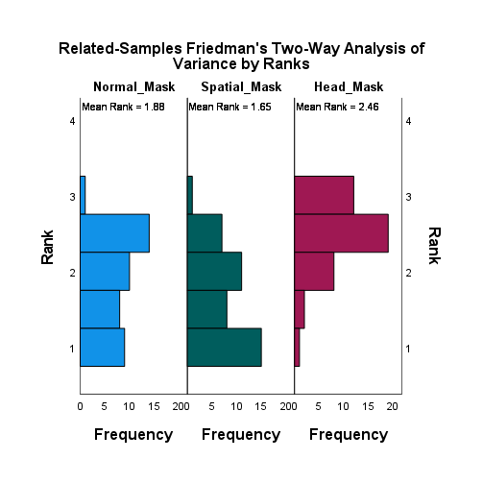

|  |  |  |  |  |  |
| --- | --- | --- | --- | --- | --- |
| **Pairwise Comparisons** | | | | | |
| Sample 1-Sample 2 | Test Statistic | Std. Error | Std. Test Statistic | Sig. | Adj. Sig.a |
| Spatial_Mask-Normal_Mask | ,226 | ,218 | 1,037 | ,300 | ,900 |
| Spatial_Mask-Head_Mask | -,810 | ,218 | -3,710 | ,000 | ,001 |
| Normal_Mask-Head_Mask | -,583 | ,218 | -2,673 | ,008 | ,023 |
| Each row tests the null hypothesis that the Sample 1 and Sample 2 distributions are the same.  Asymptotic significances (2-sided tests) are displayed. The significance level is ,050. | | | | | |
| a. Significance values have been adjusted by the Bonferroni correction for multiple tests. | | | | | |

|  |  |  |  |  |
| --- | --- | --- | --- | --- |
| **Ranks** | | | | |
|  | | N | Mean Rank | Sum of Ranks |
| Head_Mask - Normal_Mask | Negative Ranks | 2a | 12,50 | 25,00 |
| Positive Ranks | 18b | 10,28 | 185,00 |
| Ties | 22c |  |  |
| Total | 42 |  |  |
| Head_Mask - Spatial_Mask | Negative Ranks | 2d | 11,00 | 22,00 |
| Positive Ranks | 25e | 14,24 | 356,00 |
| Ties | 15f |  |  |
| Total | 42 |  |  |
| a. Head_Mask < Normal_Mask | | | | |
| b. Head_Mask > Normal_Mask | | | | |
| c. Head_Mask = Normal_Mask | | | | |
| d. Head_Mask < Spatial_Mask | | | | |
| e. Head_Mask > Spatial_Mask | | | | |
| f. Head_Mask = Spatial_Mask | | | | |

|  |  |  |
| --- | --- | --- |
| **Test Statisticsa** | | |
|  | Head_Mask - Normal_Mask | Head_Mask - Spatial_Mask |
| Z | -3,123b | -4,259b |
| Asymp. Sig. (2-tailed) | ,002 | ,000 |
| a. Wilcoxon Signed Ranks Test | | |
| b. Based on negative ranks. | | |

|  |  |  |  |  |
| --- | --- | --- | --- | --- |
| **Ranks** | | | | |
|  | | N | Mean Rank | Sum of Ranks |
| Spatial_Mask - Normal_Mask | Negative Ranks | 16a | 14,38 | 230,00 |
| Positive Ranks | 10b | 12,10 | 121,00 |
| Ties | 16c |  |  |
| Total | 42 |  |  |
| a. Spatial_Mask < Normal_Mask | | | | |
| b. Spatial_Mask > Normal_Mask | | | | |
| c. Spatial_Mask = Normal_Mask | | | | |

|  |  |
| --- | --- |
| **Test Statisticsa** | |
|  | Spatial_Mask - Normal_Mask |
| Z | -1,447b |
| Asymp. Sig. (2-tailed) | ,148 |
| a. Wilcoxon Signed Ranks Test | |
| b. Based on positive ranks. | |

## Comprehension confidence

How confident are you with your previous answers?

* 1 = Very little confidence
* 2 = Little confidence
* 3 = Neutral
* 4 = Confident
* 5 = Very confident

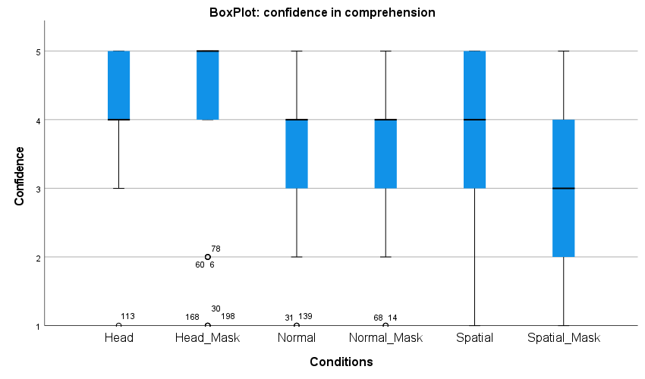

|  |  |  |  |  |  |  |  |
| --- | --- | --- | --- | --- | --- | --- | --- |
| **Statistics** | | | | | | | |
|  | | Normal | Normal_Mask | Spatial | Spatial_Mask | Head | Head_Mask |
| N | Valid | 42 | 42 | 42 | 42 | 42 | 42 |
| Missing | 0 | 0 | 0 | 0 | 0 | 0 |
| Mean | | 3,62 | 3,67 | 3,60 | 3,00 | 4,24 | 4,14 |
| Median | | 4,00 | 4,00 | 4,00 | 3,00 | 4,00 | 5,00 |
| Std. Deviation | | ,909 | 1,097 | 1,211 | 1,230 | ,790 | 1,260 |
| Variance | | ,827 | 1,203 | 1,466 | 1,512 | ,625 | 1,589 |
| Minimum | | 1 | 1 | 1 | 1 | 1 | 1 |
| Maximum | | 5 | 5 | 5 | 5 | 5 | 5 |
| Sum | | 152 | 154 | 151 | 126 | 178 | 174 |
| Percentiles | 25 | 3,00 | 3,00 | 2,75 | 2,00 | 4,00 | 4,00 |
| 50 | 4,00 | 4,00 | 4,00 | 3,00 | 4,00 | 5,00 |
| 75 | 4,00 | 4,00 | 5,00 | 4,00 | 5,00 | 5,00 |

**Frequency Table**

|  |  |  |  |  |  |
| --- | --- | --- | --- | --- | --- |
| **Normal** | | | | | |
|  | | Frequency | Percent | Valid Percent | Cumulative Percent |
| Valid | Very little confidence | 2 | 4,8 | 4,8 | 4,8 |
| Little confidence | 2 | 4,8 | 4,8 | 9,5 |
| Neutral | 10 | 23,8 | 23,8 | 33,3 |
| Confident | 24 | 57,1 | 57,1 | 90,5 |
| Very confident | 4 | 9,5 | 9,5 | 100,0 |
| Total | 42 | 100,0 | 100,0 |  |

|  |  |  |  |  |  |
| --- | --- | --- | --- | --- | --- |
| **Normal_Mask** | | | | | |
|  | | Frequency | Percent | Valid Percent | Cumulative Percent |
| Valid | Very little confidence | 2 | 4,8 | 4,8 | 4,8 |
| Little confidence | 5 | 11,9 | 11,9 | 16,7 |
| Neutral | 7 | 16,7 | 16,7 | 33,3 |
| Confident | 19 | 45,2 | 45,2 | 78,6 |
| Very confident | 9 | 21,4 | 21,4 | 100,0 |
| Total | 42 | 100,0 | 100,0 |  |

|  |  |  |  |  |  |
| --- | --- | --- | --- | --- | --- |
| **Spatial** | | | | | |
|  | | Frequency | Percent | Valid Percent | Cumulative Percent |
| Valid | Very little confidence | 2 | 4,8 | 4,8 | 4,8 |
| Little confidence | 8 | 19,0 | 19,0 | 23,8 |
| Neutral | 6 | 14,3 | 14,3 | 38,1 |
| Confident | 15 | 35,7 | 35,7 | 73,8 |
| Very confident | 11 | 26,2 | 26,2 | 100,0 |
| Total | 42 | 100,0 | 100,0 |  |

|  |  |  |  |  |  |
| --- | --- | --- | --- | --- | --- |
| **Spatial_Mask** | | | | | |
|  | | Frequency | Percent | Valid Percent | Cumulative Percent |
| Valid | Very little confidence | 4 | 9,5 | 9,5 | 9,5 |
| Little confidence | 14 | 33,3 | 33,3 | 42,9 |
| Neutral | 7 | 16,7 | 16,7 | 59,5 |
| Confident | 12 | 28,6 | 28,6 | 88,1 |
| Very confident | 5 | 11,9 | 11,9 | 100,0 |
| Total | 42 | 100,0 | 100,0 |  |

|  |  |  |  |  |  |
| --- | --- | --- | --- | --- | --- |
| **Head** | | | | | |
|  | | Frequency | Percent | Valid Percent | Cumulative Percent |
| Valid | Very little confidence | 1 | 2,4 | 2,4 | 2,4 |
| Neutral | 3 | 7,1 | 7,1 | 9,5 |
| Confident | 22 | 52,4 | 52,4 | 61,9 |
| Very confident | 16 | 38,1 | 38,1 | 100,0 |
| Total | 42 | 100,0 | 100,0 |  |

|  |  |  |  |  |  |
| --- | --- | --- | --- | --- | --- |
| **Head_Mask** | | | | | |
|  | | Frequency | Percent | Valid Percent | Cumulative Percent |
| Valid | Very little confidence | 3 | 7,1 | 7,1 | 7,1 |
| Little confidence | 4 | 9,5 | 9,5 | 16,7 |
| Confident | 12 | 28,6 | 28,6 | 45,2 |
| Very confident | 23 | 54,8 | 54,8 | 100,0 |
| Total | 42 | 100,0 | 100,0 |  |

### Significance tests

#### No mask vs Mask

##### Friedman

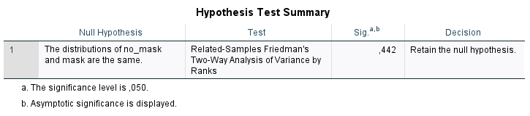

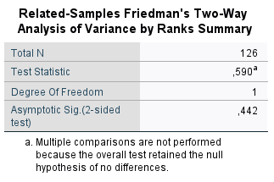

No interaction effect between mask and no mask.

#### No mask

|  |  |  |  |  |  |
| --- | --- | --- | --- | --- | --- |
| **Levene's Test of Equality of Error Variancesa,b** | | | | | |
|  | | Levene Statistic | df1 | df2 | Sig. |
| CompConf | Based on Mean | 6,699 | 2 | 123 | ,002 |
| Based on Median | 3,438 | 2 | 123 | ,035 |
| Based on Median and with adjusted df | 3,438 | 2 | 116,105 | ,035 |
| Based on trimmed mean | 5,701 | 2 | 123 | ,004 |
| Tests the null hypothesis that the error variance of the dependent variable is equal across groups. | | | | | |
| a. Dependent variable: CompConf | | | | | |
| b. Design: Intercept + NoMask | | | | | |

Homogeneous variances : Not ok => ANOVA can’t be performed.

|  |  |  |  |  |  |  |  |
| --- | --- | --- | --- | --- | --- | --- | --- |
| **Tests of Normality** | | | | | | | |
|  | NoMask | Kolmogorov-Smirnova | | | Shapiro-Wilk | | |
|  | Statistic | df | Sig. | Statistic | df | Sig. |
| CompConf | Head | ,286 | 42 | ,000 | ,727 | 42 | ,000 |
| Normal | ,329 | 42 | ,000 | ,801 | 42 | ,000 |
| Spatial | ,250 | 42 | ,000 | ,872 | 42 | ,000 |
| a. Lilliefors Significance Correction | | | | | | | |

Normal distribution: Not ok => ANOVA can’t be performed.

|  |  |  |  |  |  |
| --- | --- | --- | --- | --- | --- |
| **ANOVA** | | | | | |
| CompConf | | | | | |
|  | Sum of Squares | df | Mean Square | F | Sig. |
| Between Groups | 11,159 | 2 | 5,579 | 5,736 | ,004 |
| Within Groups | 119,643 | 123 | ,973 |  |  |
| Total | 130,802 | 125 |  |  |  |

**Kruskal-Wallis test:**

|  |  |  |  |  |
| --- | --- | --- | --- | --- |
| **Hypothesis Test Summary** | | | | |
|  | Null Hypothesis | Test | Sig.a,b | Decision |
| 1 | The distribution of CompConf is the same across categories of NoMask. | Independent-Samples Kruskal-Wallis Test | ,002 | Reject the null hypothesis. |
| a. The significance level is ,050. | | | | |
| b. Asymptotic significance is displayed. | | | | |

|  |  |
| --- | --- |
| **Independent-Samples Kruskal-Wallis Test Summary** | |
| Total N | 126 |
| Test Statistic | 11,997a |
| Degree Of Freedom | 2 |
| Asymptotic Sig.(2-sided test) | ,002 |
| a. The test statistic is adjusted for ties. | |

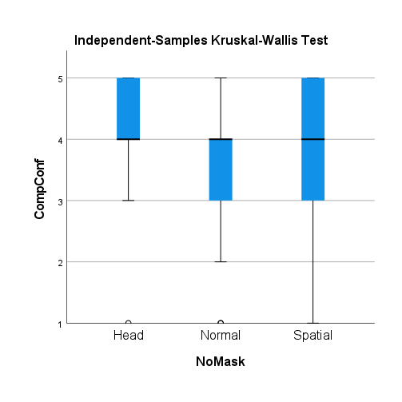

|  |  |  |  |  |  |
| --- | --- | --- | --- | --- | --- |
| **Pairwise Comparisons of NoMask** | | | | | |
| Sample 1-Sample 2 | Test Statistic | Std. Error | Std. Test Statistic | Sig. | Adj. Sig.a |
| Normal-Spatial | -3,690 | 7,423 | -,497 | ,619 | 1,000 |
| Normal-Head | 23,881 | 7,423 | 3,217 | ,001 | ,004 |
| Spatial-Head | 20,190 | 7,423 | 2,720 | ,007 | ,020 |
| Each row tests the null hypothesis that the Sample 1 and Sample 2 distributions are the same.  Asymptotic significances (2-sided tests) are displayed. The significance level is ,050. | | | | | |
| a. Significance values have been adjusted by the Bonferroni correction for multiple tests. | | | | | |

**There is a significative difference between Head and the other conditions. Head leads to a better comprehension confidence.**

##### Friedman SIGNIFICANT

|  |  |  |  |  |
| --- | --- | --- | --- | --- |
| **Hypothesis Test Summary** | | | | |
|  | Null Hypothesis | Test | Sig.a,b | Decision |
| 1 | The distributions of Normal, Spatial and Head are the same. | Related-Samples Friedman's Two-Way Analysis of Variance by Ranks | ,005 | Reject the null hypothesis. |
| a. The significance level is ,050. | | | | |
| b. Asymptotic significance is displayed. | | | | |

|  |  |
| --- | --- |
| **Related-Samples Friedman's Two-Way Analysis of Variance by Ranks Summary** | |
| Total N | 42 |
| Test Statistic | 10,606 |
| Degree Of Freedom | 2 |
| Asymptotic Sig.(2-sided test) | ,005 |

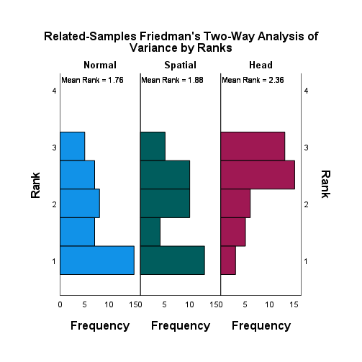

|  |  |  |  |  |  |
| --- | --- | --- | --- | --- | --- |
| **Pairwise Comparisons** | | | | | |
| Sample 1-Sample 2 | Test Statistic | Std. Error | Std. Test Statistic | Sig. | Adj. Sig.a |
| Normal-Spatial | -,119 | ,218 | -,546 | ,585 | 1,000 |
| Normal-Head | -,595 | ,218 | -2,728 | ,006 | ,019 |
| Spatial-Head | -,476 | ,218 | -2,182 | ,029 | ,087 |
| Each row tests the null hypothesis that the Sample 1 and Sample 2 distributions are the same.  Asymptotic significances (2-sided tests) are displayed. The significance level is ,050. | | | | | |
| a. Significance values have been adjusted by the Bonferroni correction for multiple tests. | | | | | |

|  |  |  |  |  |
| --- | --- | --- | --- | --- |
| **Ranks** | | | | |
|  | | N | Mean Rank | Sum of Ranks |
| Head - Normal | Negative Ranks | 6a | 14,33 | 86,00 |
| Positive Ranks | 23b | 15,17 | 349,00 |
| Ties | 13c |  |  |
| Total | 42 |  |  |
| Head - Spatial | Negative Ranks | 8d | 10,13 | 81,00 |
| Positive Ranks | 21e | 16,86 | 354,00 |
| Ties | 13f |  |  |
| Total | 42 |  |  |
| Spatial - Normal | Negative Ranks | 16g | 19,91 | 318,50 |
| Positive Ranks | 19h | 16,39 | 311,50 |
| Ties | 7i |  |  |
| Total | 42 |  |  |
| a. Head < Normal | | | | |
| b. Head > Normal | | | | |
| c. Head = Normal | | | | |
| d. Head < Spatial | | | | |
| e. Head > Spatial | | | | |
| f. Head = Spatial | | | | |
| g. Spatial < Normal | | | | |
| h. Spatial > Normal | | | | |
| i. Spatial = Normal | | | | |

|  |  |  |  |
| --- | --- | --- | --- |
| **Test Statisticsa** | | | |
|  | Head - Normal | Head - Spatial | Spatial - Normal |
| Z | -2,925b | -3,028b | -,059c |
| Asymp. Sig. (2-tailed) | ,003 | ,002 | ,953 |
| a. Wilcoxon Signed Ranks Test | | | |
| b. Based on negative ranks. | | | |
| c. Based on positive ranks. | | | |

#### Mask

|  |  |  |  |  |  |
| --- | --- | --- | --- | --- | --- |
| **Levene's Test of Equality of Error Variancesa,b** | | | | | |
|  | | Levene Statistic | df1 | df2 | Sig. |
| CompConf | Based on Mean | ,655 | 2 | 123 | ,521 |
| Based on Median | ,988 | 2 | 123 | ,375 |
| Based on Median and with adjusted df | ,988 | 2 | 93,440 | ,376 |
| Based on trimmed mean | ,796 | 2 | 123 | ,454 |
| Tests the null hypothesis that the error variance of the dependent variable is equal across groups. | | | | | |
| a. Dependent variable: CompConf | | | | | |
| b. Design: Intercept + Mask | | | | | |

Homogeneous variances : OK

|  |  |  |  |  |  |  |  |
| --- | --- | --- | --- | --- | --- | --- | --- |
| **Tests of Normality** | | | | | | | |
|  | Mask | Kolmogorov-Smirnova | | | Shapiro-Wilk | | |
|  | Statistic | df | Sig. | Statistic | df | Sig. |
| CompConf | Head | ,299 | 42 | ,000 | ,689 | 42 | ,000 |
| Normal | ,286 | 42 | ,000 | ,862 | 42 | ,000 |
| Spatial | ,221 | 42 | ,000 | ,896 | 42 | ,001 |
| a. Lilliefors Significance Correction | | | | | | | |

Normal distribution: Not ok => ANOVA can’t be performed.

|  |  |  |  |  |  |
| --- | --- | --- | --- | --- | --- |
| **ANOVA** | | | | | |
| CompConf | | | | | |
|  | Sum of Squares | df | Mean Square | F | Sig. |
| Between Groups | 27,683 | 2 | 13,841 | 9,647 | ,000 |
| Within Groups | 176,476 | 123 | 1,435 |  |  |
| Total | 204,159 | 125 |  |  |  |

**Kruskal-Wallis Test:**

|  |  |  |  |  |
| --- | --- | --- | --- | --- |
| **Hypothesis Test Summary** | | | | |
|  | Null Hypothesis | Test | Sig.a,b | Decision |
| 1 | The distribution of CompConf is the same across categories of Mask. | Independent-Samples Kruskal-Wallis Test | ,000 | Reject the null hypothesis. |
| a. The significance level is ,050. | | | | |
| b. Asymptotic significance is displayed. | | | | |

|  |  |
| --- | --- |
| **Independent-Samples Kruskal-Wallis Test Summary** | |
| Total N | 126 |
| Test Statistic | 20,318a |
| Degree Of Freedom | 2 |
| Asymptotic Sig.(2-sided test) | ,000 |
| a. The test statistic is adjusted for ties. | |

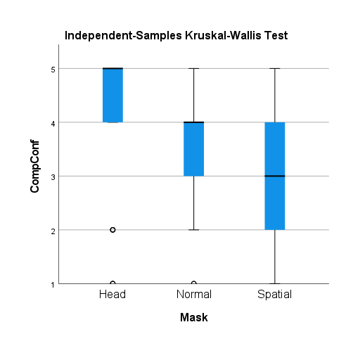

|  |  |  |  |  |  |
| --- | --- | --- | --- | --- | --- |
| **Pairwise Comparisons of Mask** | | | | | |
| Sample 1-Sample 2 | Test Statistic | Std. Error | Std. Test Statistic | Sig. | Adj. Sig.a |
| Spatial-Normal | 16,881 | 7,673 | 2,200 | ,028 | ,083 |
| Spatial-Head | 34,583 | 7,673 | 4,507 | ,000 | ,000 |
| Normal-Head | 17,702 | 7,673 | 2,307 | ,021 | ,063 |
| Each row tests the null hypothesis that the Sample 1 and Sample 2 distributions are the same.  Asymptotic significances (2-sided tests) are displayed. The significance level is ,050. | | | | | |
| a. Significance values have been adjusted by the Bonferroni correction for multiple tests. | | | | | |

**Without taking Bonferroni correction, there is a significant difference between all the conditions with masks, with Head generating the best comprehension confidence.**

##### Friedman SIGNIFICANT

|  |  |  |  |  |
| --- | --- | --- | --- | --- |
| **Hypothesis Test Summary** | | | | |
|  | Null Hypothesis | Test | Sig.a,b | Decision |
| 1 | The distributions of Normal_Mask, Spatial_Mask and Head_Mask are the same. | Related-Samples Friedman's Two-Way Analysis of Variance by Ranks | ,000 | Reject the null hypothesis. |
| a. The significance level is ,050. | | | | |
| b. Asymptotic significance is displayed. | | | | |

|  |  |
| --- | --- |
| **Related-Samples Friedman's Two-Way Analysis of Variance by Ranks Summary** | |
| Total N | 42 |
| Test Statistic | 17,671 |
| Degree Of Freedom | 2 |
| Asymptotic Sig.(2-sided test) | ,000 |

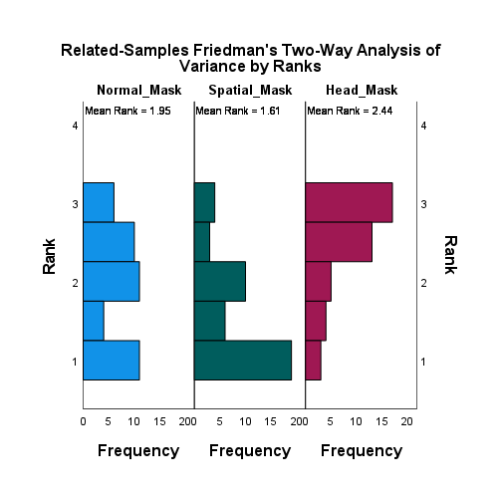

|  |  |  |  |  |  |
| --- | --- | --- | --- | --- | --- |
| **Pairwise Comparisons** | | | | | |
| Sample 1-Sample 2 | Test Statistic | Std. Error | Std. Test Statistic | Sig. | Adj. Sig.a |
| Spatial_Mask-Normal_Mask | ,345 | ,218 | 1,582 | ,114 | ,341 |
| Spatial_Mask-Head_Mask | -,833 | ,218 | -3,819 | ,000 | ,000 |
| Normal_Mask-Head_Mask | -,488 | ,218 | -2,237 | ,025 | ,076 |
| Each row tests the null hypothesis that the Sample 1 and Sample 2 distributions are the same.  Asymptotic significances (2-sided tests) are displayed. The significance level is ,050. | | | | | |
| a. Significance values have been adjusted by the Bonferroni correction for multiple tests. | | | | | |

|  |  |  |  |  |
| --- | --- | --- | --- | --- |
| **Ranks** | | | | |
|  | | N | Mean Rank | Sum of Ranks |
| Spatial_Mask - Normal_Mask | Negative Ranks | 23a | 22,76 | 523,50 |
| Positive Ranks | 14b | 12,82 | 179,50 |
| Ties | 5c |  |  |
| Total | 42 |  |  |
| Head_Mask - Normal_Mask | Negative Ranks | 8d | 16,81 | 134,50 |
| Positive Ranks | 21e | 14,31 | 300,50 |
| Ties | 13f |  |  |
| Total | 42 |  |  |
| Head_Mask - Spatial_Mask | Negative Ranks | 5g | 14,40 | 72,00 |
| Positive Ranks | 29h | 18,03 | 523,00 |
| Ties | 8i |  |  |
| Total | 42 |  |  |
| a. Spatial_Mask < Normal_Mask | | | | |
| b. Spatial_Mask > Normal_Mask | | | | |
| c. Spatial_Mask = Normal_Mask | | | | |
| d. Head_Mask < Normal_Mask | | | | |
| e. Head_Mask > Normal_Mask | | | | |
| f. Head_Mask = Normal_Mask | | | | |
| g. Head_Mask < Spatial_Mask | | | | |
| h. Head_Mask > Spatial_Mask | | | | |
| i. Head_Mask = Spatial_Mask | | | | |

|  |  |  |  |
| --- | --- | --- | --- |
| **Test Statisticsa** | | | |
|  | Spatial_Mask - Normal_Mask | Head_Mask - Normal_Mask | Head_Mask - Spatial_Mask |
| Z | -2,647b | -1,829c | -3,910c |
| Asymp. Sig. (2-tailed) | ,008 | ,067 | ,000 |
| a. Wilcoxon Signed Ranks Test | | | |
| b. Based on positive ranks. | | | |
| c. Based on negative ranks. | | | |

## Post Conference: speaker identification difficulty

During the conference, determining which conferee was speaking was:

* 1 = Very difficult
* 2 = Difficult
* 3 = Normal
* 4 = Easy
* 5 = Very Easy

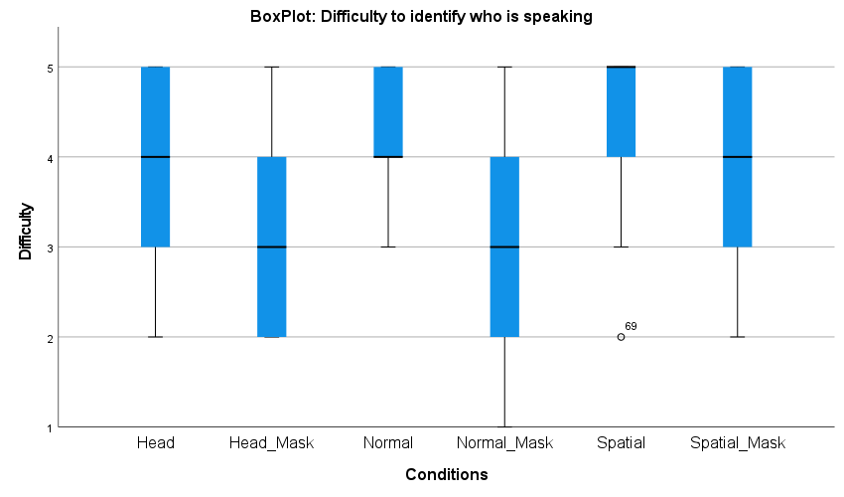

|  |  |  |  |  |  |  |  |
| --- | --- | --- | --- | --- | --- | --- | --- |
| **Statistics** | | | | | | | |
|  | | Normal | Normal_Mask | Spatial | Spatial_Mask | Head | Head_Mask |
| N | Valid | 42 | 42 | 42 | 42 | 42 | 42 |
| Missing | 0 | 0 | 0 | 0 | 0 | 0 |
| Mean | | 4,26 | 3,14 | 4,45 | 3,64 | 4,00 | 3,02 |
| Median | | 4,00 | 3,00 | 5,00 | 4,00 | 4,00 | 3,00 |
| Std. Deviation | | ,734 | 1,049 | ,670 | 1,122 | ,937 | 1,024 |
| Variance | | ,539 | 1,101 | ,449 | 1,260 | ,878 | 1,048 |
| Minimum | | 3 | 1 | 2 | 2 | 2 | 2 |
| Maximum | | 5 | 5 | 5 | 5 | 5 | 5 |
| Sum | | 179 | 132 | 187 | 153 | 168 | 127 |
| Percentiles | 25 | 4,00 | 2,00 | 4,00 | 2,75 | 3,00 | 2,00 |
| 50 | 4,00 | 3,00 | 5,00 | 4,00 | 4,00 | 3,00 |
| 75 | 5,00 | 4,00 | 5,00 | 5,00 | 5,00 | 4,00 |

**Frequency Table**

|  |  |  |  |  |  |
| --- | --- | --- | --- | --- | --- |
| **Normal** | | | | | |
|  | | Frequency | Percent | Valid Percent | Cumulative Percent |
| Valid | Normal | 7 | 16,7 | 16,7 | 16,7 |
| Easy | 17 | 40,5 | 40,5 | 57,1 |
| Very easy | 18 | 42,9 | 42,9 | 100,0 |
| Total | 42 | 100,0 | 100,0 |  |

|  |  |  |  |  |  |
| --- | --- | --- | --- | --- | --- |
| **Normal_Mask** | | | | | |
|  | | Frequency | Percent | Valid Percent | Cumulative Percent |
| Valid | Very difficult | 1 | 2,4 | 2,4 | 2,4 |
| Difficult | 13 | 31,0 | 31,0 | 33,3 |
| Normal | 11 | 26,2 | 26,2 | 59,5 |
| Easy | 13 | 31,0 | 31,0 | 90,5 |
| Very easy | 4 | 9,5 | 9,5 | 100,0 |
| Total | 42 | 100,0 | 100,0 |  |

|  |  |  |  |  |  |
| --- | --- | --- | --- | --- | --- |
| **Spatial** | | | | | |
|  | | Frequency | Percent | Valid Percent | Cumulative Percent |
| Valid | Difficult | 1 | 2,4 | 2,4 | 2,4 |
| Normal | 1 | 2,4 | 2,4 | 4,8 |
| Easy | 18 | 42,9 | 42,9 | 47,6 |
| Very easy | 22 | 52,4 | 52,4 | 100,0 |
| Total | 42 | 100,0 | 100,0 |  |

|  |  |  |  |  |  |
| --- | --- | --- | --- | --- | --- |
| **Spatial_Mask** | | | | | |
|  | | Frequency | Percent | Valid Percent | Cumulative Percent |
| Valid | Difficult | 10 | 23,8 | 23,8 | 23,8 |
| Normal | 6 | 14,3 | 14,3 | 38,1 |
| Easy | 15 | 35,7 | 35,7 | 73,8 |
| Very easy | 11 | 26,2 | 26,2 | 100,0 |
| Total | 42 | 100,0 | 100,0 |  |

|  |  |  |  |  |  |
| --- | --- | --- | --- | --- | --- |
| **Head** | | | | | |
|  | | Frequency | Percent | Valid Percent | Cumulative Percent |
| Valid | Difficult | 3 | 7,1 | 7,1 | 7,1 |
| Normal | 9 | 21,4 | 21,4 | 28,6 |
| Easy | 15 | 35,7 | 35,7 | 64,3 |
| Very easy | 15 | 35,7 | 35,7 | 100,0 |
| Total | 42 | 100,0 | 100,0 |  |

|  |  |  |  |  |  |
| --- | --- | --- | --- | --- | --- |
| **Head_Mask** | | | | | |
|  | | Frequency | Percent | Valid Percent | Cumulative Percent |
| Valid | Difficult | 17 | 40,5 | 40,5 | 40,5 |
| Normal | 11 | 26,2 | 26,2 | 66,7 |
| Easy | 10 | 23,8 | 23,8 | 90,5 |
| Very easy | 4 | 9,5 | 9,5 | 100,0 |
| Total | 42 | 100,0 | 100,0 |  |

### Significance tests

#### No mask vs mask SIGNIFICANT

##### Friedman

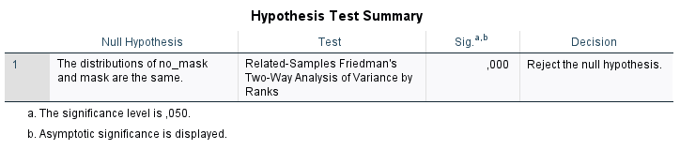

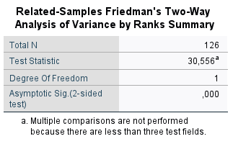

##### Wilcoxon

|  |  |  |  |  |  |
| --- | --- | --- | --- | --- | --- |
| **Descriptive Statistics** | | | | | |
|  | N | Mean | Std. Deviation | Minimum | Maximum |
| Normal | 42 | 4,26 | ,734 | 3 | 5 |
| Spatial | 42 | 4,45 | ,670 | 2 | 5 |
| Head | 42 | 4,00 | ,937 | 2 | 5 |
| Normal_Mask | 42 | 3,14 | 1,049 | 1 | 5 |
| Spatial_Mask | 42 | 3,64 | 1,122 | 2 | 5 |
| Head_Mask | 42 | 3,02 | 1,024 | 2 | 5 |

|  |  |  |  |  |
| --- | --- | --- | --- | --- |
| **Ranks** | | | | |
|  | | N | Mean Rank | Sum of Ranks |
| Normal_Mask - Normal | Negative Ranks | 28a | 18,82 | 527,00 |
| Positive Ranks | 6b | 11,33 | 68,00 |
| Ties | 8c |  |  |
| Total | 42 |  |  |
| Spatial_Mask - Spatial | Negative Ranks | 24d | 18,67 | 448,00 |
| Positive Ranks | 8e | 10,00 | 80,00 |
| Ties | 10f |  |  |
| Total | 42 |  |  |
| Head_Mask - Head | Negative Ranks | 25g | 19,18 | 479,50 |
| Positive Ranks | 8h | 10,19 | 81,50 |
| Ties | 9i |  |  |
| Total | 42 |  |  |
| a. Normal_Mask < Normal | | | | |
| b. Normal_Mask > Normal | | | | |
| c. Normal_Mask = Normal | | | | |
| d. Spatial_Mask < Spatial | | | | |
| e. Spatial_Mask > Spatial | | | | |
| f. Spatial_Mask = Spatial | | | | |
| g. Head_Mask < Head | | | | |
| h. Head_Mask > Head | | | | |
| i. Head_Mask = Head | | | | |

|  |  |  |  |
| --- | --- | --- | --- |
| **Test Statisticsa** | | | |
|  | Normal_Mask - Normal | Spatial_Mask - Spatial | Head_Mask - Head |
| Z | -3,983b | -3,538b | -3,609b |
| Asymp. Sig. (2-tailed) | ,000 | ,000 | ,000 |
| a. Wilcoxon Signed Ranks Test | | | |
| b. Based on positive ranks. | | | |

There is an interaction effect between no mask and mask. All audio formats in the visual condition without mask lead to an easier speaker identification difficulty.

#### No mask

|  |  |  |  |  |  |
| --- | --- | --- | --- | --- | --- |
| **Levene's Test of Equality of Error Variancesa,b** | | | | | |
|  | | Levene Statistic | df1 | df2 | Sig. |
| DifIdSpk | Based on Mean | 1,053 | 2 | 123 | ,352 |
| Based on Median | ,883 | 2 | 123 | ,416 |
| Based on Median and with adjusted df | ,883 | 2 | 116,527 | ,416 |
| Based on trimmed mean | 1,399 | 2 | 123 | ,251 |
| Tests the null hypothesis that the error variance of the dependent variable is equal across groups. | | | | | |
| a. Dependent variable: DifIdSpk | | | | | |
| b. Design: Intercept + NoMask | | | | | |

Homogeneous variances : Not ok => ANOVA can’t be performed.

|  |  |  |  |  |  |  |  |
| --- | --- | --- | --- | --- | --- | --- | --- |
| **Tests of Normality** | | | | | | | |
|  | NoMask | Kolmogorov-Smirnova | | | Shapiro-Wilk | | |
|  | Statistic | df | Sig. | Statistic | df | Sig. |
| DifIdSpk | Head | ,214 | 42 | ,000 | ,844 | 42 | ,000 |
| Normal | ,271 | 42 | ,000 | ,785 | 42 | ,000 |
| Spatial | ,317 | 42 | ,000 | ,706 | 42 | ,000 |
| a. Lilliefors Significance Correction | | | | | | | |

Normal distribution: not ok. ANOVA can’t be performed.

|  |  |  |  |  |  |
| --- | --- | --- | --- | --- | --- |
| **ANOVA** | | | | | |
| DifIdSpk | | | | | |
|  | Sum of Squares | df | Mean Square | F | Sig. |
| Between Groups | 4,333 | 2 | 2,167 | 3,483 | ,034 |
| Within Groups | 76,524 | 123 | ,622 |  |  |
| Total | 80,857 | 125 |  |  |  |

* Would have a significant difference with ANOVA.

**Kruskal-Wallis Test:**

|  |  |  |  |  |
| --- | --- | --- | --- | --- |
| **Hypothesis Test Summary** | | | | |
|  | Null Hypothesis | Test | Sig.a,b | Decision |
| 1 | The distribution of DifIdSpk is the same across categories of NoMask. | Independent-Samples Kruskal-Wallis Test | ,064 | Retain the null hypothesis. |
| a. The significance level is ,050. | | | | |
| b. Asymptotic significance is displayed. | | | | |

|  |  |
| --- | --- |
| **Independent-Samples Kruskal-Wallis Test Summary** | |
| Total N | 126 |
| Test Statistic | 5,486a,b |
| Degree Of Freedom | 2 |
| Asymptotic Sig.(2-sided test) | ,064 |
| a. The test statistic is adjusted for ties. | |
| b. Multiple comparisons are not performed because the overall test does not show significant differences across samples. | |

No significant difference.

##### Friedman SIGNIFICANT

|  |  |  |  |  |
| --- | --- | --- | --- | --- |
| **Hypothesis Test Summary** | | | | |
|  | Null Hypothesis | Test | Sig.a,b | Decision |
| 1 | The distributions of Normal, Spatial and Head are the same. | Related-Samples Friedman's Two-Way Analysis of Variance by Ranks | ,031 | Reject the null hypothesis. |
| a. The significance level is ,050. | | | | |
| b. Asymptotic significance is displayed. | | | | |

|  |  |
| --- | --- |
| **Related-Samples Friedman's Two-Way Analysis of Variance by Ranks Summary** | |
| Total N | 42 |
| Test Statistic | 6,933 |
| Degree Of Freedom | 2 |
| Asymptotic Sig.(2-sided test) | ,031 |

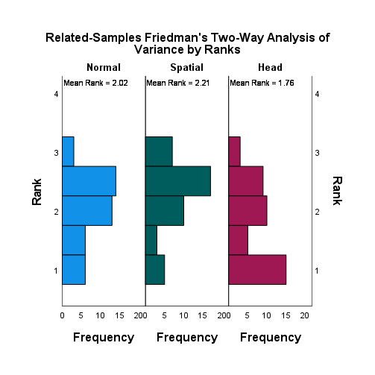

|  |  |  |  |  |  |
| --- | --- | --- | --- | --- | --- |
| **Pairwise Comparisons** | | | | | |
| Sample 1-Sample 2 | Test Statistic | Std. Error | Std. Test Statistic | Sig. | Adj. Sig.a |
| Head-Normal | ,262 | ,218 | 1,200 | ,230 | ,690 |
| Head-Spatial | ,452 | ,218 | 2,073 | ,038 | ,114 |
| Normal-Spatial | -,190 | ,218 | -,873 | ,383 | 1,000 |
| Each row tests the null hypothesis that the Sample 1 and Sample 2 distributions are the same.  Asymptotic significances (2-sided tests) are displayed. The significance level is ,050. | | | | | |
| a. Significance values have been adjusted by the Bonferroni correction for multiple tests. | | | | | |

|  |  |  |  |  |
| --- | --- | --- | --- | --- |
| **Ranks** | | | | |
|  | | N | Mean Rank | Sum of Ranks |
| Spatial - Normal | Negative Ranks | 7a | 9,93 | 69,50 |
| Positive Ranks | 13b | 10,81 | 140,50 |
| Ties | 22c |  |  |
| Total | 42 |  |  |
| Head - Normal | Negative Ranks | 17d | 13,62 | 231,50 |
| Positive Ranks | 9e | 13,28 | 119,50 |
| Ties | 16f |  |  |
| Total | 42 |  |  |
| Head - Spatial | Negative Ranks | 19g | 14,32 | 272,00 |
| Positive Ranks | 7h | 11,29 | 79,00 |
| Ties | 16i |  |  |
| Total | 42 |  |  |
| a. Spatial < Normal | | | | |
| b. Spatial > Normal | | | | |
| c. Spatial = Normal | | | | |
| d. Head < Normal | | | | |
| e. Head > Normal | | | | |
| f. Head = Normal | | | | |
| g. Head < Spatial | | | | |
| h. Head > Spatial | | | | |
| i. Head = Spatial | | | | |

|  |  |  |  |
| --- | --- | --- | --- |
| **Test Statisticsa** | | | |
|  | Spatial - Normal | Head - Normal | Head - Spatial |
| Z | -1,413b | -1,507c | -2,559c |
| Asymp. Sig. (2-tailed) | ,158 | ,132 | ,010 |
| a. Wilcoxon Signed Ranks Test | | | |
| b. Based on negative ranks. | | | |
| c. Based on positive ranks. | | | |

#### Mask

|  |  |  |  |  |  |
| --- | --- | --- | --- | --- | --- |
| **Levene's Test of Equality of Error Variancesa,b** | | | | | |
|  | | Levene Statistic | df1 | df2 | Sig. |
| DifIdSpk | Based on Mean | ,546 | 2 | 123 | ,581 |
| Based on Median | ,055 | 2 | 123 | ,947 |
| Based on Median and with adjusted df | ,055 | 2 | 114,961 | ,947 |
| Based on trimmed mean | ,522 | 2 | 123 | ,595 |
| Tests the null hypothesis that the error variance of the dependent variable is equal across groups. | | | | | |
| a. Dependent variable: DifIdSpk | | | | | |
| b. Design: Intercept + Mask | | | | | |

Homogeneous variances : OK.

|  |  |  |  |  |  |  |  |
| --- | --- | --- | --- | --- | --- | --- | --- |
| **Tests of Normality** | | | | | | | |
|  | Mask | Kolmogorov-Smirnova | | | Shapiro-Wilk | | |
|  | Statistic | df | Sig. | Statistic | df | Sig. |
| DifIdSpk | Head | ,246 | 42 | ,000 | ,830 | 42 | ,000 |
| Normal | ,198 | 42 | ,000 | ,891 | 42 | ,001 |
| Spatial | ,244 | 42 | ,000 | ,841 | 42 | ,000 |
| a. Lilliefors Significance Correction | | | | | | | |

Normal distribution: not ok. ANOVA can’t be performed.

|  |  |  |  |  |  |
| --- | --- | --- | --- | --- | --- |
| **ANOVA** | | | | | |
| DifIdSpk | | | | | |
|  | Sum of Squares | df | Mean Square | F | Sig. |
| Between Groups | 9,063 | 2 | 4,532 | 3,988 | ,021 |
| Within Groups | 139,762 | 123 | 1,136 |  |  |
| Total | 148,825 | 125 |  |  |  |

* Would have a significant difference with ANOVA

**Kruskal-Wallis Test:**

|  |  |  |  |  |
| --- | --- | --- | --- | --- |
| **Hypothesis Test Summary** | | | | |
|  | Null Hypothesis | Test | Sig.a,b | Decision |
| 1 | The distribution of DifIdSpk is the same across categories of Mask. | Independent-Samples Kruskal-Wallis Test | ,025 | Reject the null hypothesis. |
| a. The significance level is ,050. | | | | |
| b. Asymptotic significance is displayed. | | | | |

|  |  |
| --- | --- |
| **Independent-Samples Kruskal-Wallis Test Summary** | |
| Total N | 126 |
| Test Statistic | 7,413a |
| Degree Of Freedom | 2 |
| Asymptotic Sig.(2-sided test) | ,025 |
| a. The test statistic is adjusted for ties. | |

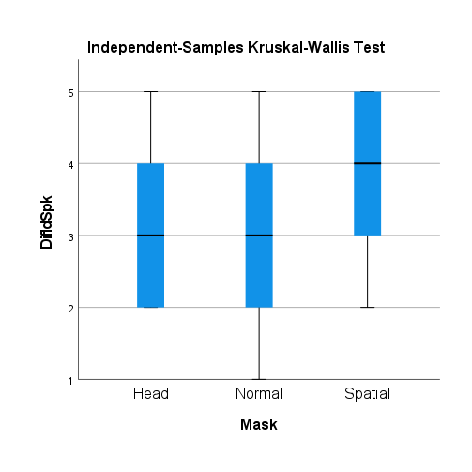

|  |  |  |  |  |  |
| --- | --- | --- | --- | --- | --- |
| **Pairwise Comparisons of Mask** | | | | | |
| Sample 1-Sample 2 | Test Statistic | Std. Error | Std. Test Statistic | Sig. | Adj. Sig.a |
| Head-Normal | -4,298 | 7,669 | -,560 | ,575 | 1,000 |
| Head-Spatial | -19,845 | 7,669 | -2,588 | ,010 | ,029 |
| Normal-Spatial | -15,548 | 7,669 | -2,027 | ,043 | ,128 |
| Each row tests the null hypothesis that the Sample 1 and Sample 2 distributions are the same.  Asymptotic significances (2-sided tests) are displayed. The significance level is ,050. | | | | | |
| a. Significance values have been adjusted by the Bonferroni correction for multiple tests. | | | | | |

**There is a significant difference between Spatial and the other conditions, in the case with mask. In the condition where conferee wear masks, the spatial audio make the subjective difficulty of identifying a speaker easier.**

##### Friedman SIGNIFICANT

|  |  |  |  |  |
| --- | --- | --- | --- | --- |
| **Hypothesis Test Summary** | | | | |
|  | Null Hypothesis | Test | Sig.a,b | Decision |
| 1 | The distributions of Normal_Mask, Spatial_Mask and Head_Mask are the same. | Related-Samples Friedman's Two-Way Analysis of Variance by Ranks | ,012 | Reject the null hypothesis. |
| a. The significance level is ,050. | | | | |
| b. Asymptotic significance is displayed. | | | | |

|  |  |
| --- | --- |
| **Related-Samples Friedman's Two-Way Analysis of Variance by Ranks Summary** | |
| Total N | 42 |
| Test Statistic | 8,918 |
| Degree Of Freedom | 2 |
| Asymptotic Sig.(2-sided test) | ,012 |

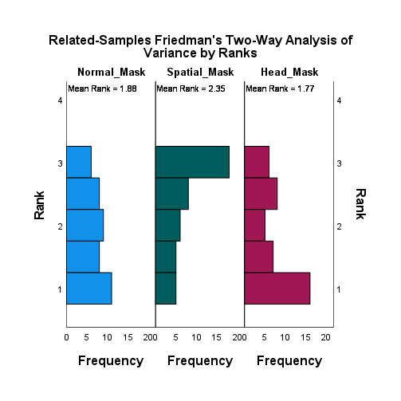

|  |  |  |  |  |  |
| --- | --- | --- | --- | --- | --- |
| **Pairwise Comparisons** | | | | | |
| Sample 1-Sample 2 | Test Statistic | Std. Error | Std. Test Statistic | Sig. | Adj. Sig.a |
| Head_Mask-Normal_Mask | ,107 | ,218 | ,491 | ,623 | 1,000 |
| Head_Mask-Spatial_Mask | ,571 | ,218 | 2,619 | ,009 | ,026 |
| Normal_Mask-Spatial_Mask | -,464 | ,218 | -2,128 | ,033 | ,100 |
| Each row tests the null hypothesis that the Sample 1 and Sample 2 distributions are the same.  Asymptotic significances (2-sided tests) are displayed. The significance level is ,050. | | | | | |
| a. Significance values have been adjusted by the Bonferroni correction for multiple tests. | | | | | |

|  |  |  |  |  |
| --- | --- | --- | --- | --- |
| **Ranks** | | | | |
|  | | N | Mean Rank | Sum of Ranks |
| Spatial_Mask - Normal_Mask | Negative Ranks | 11a | 18,68 | 205,50 |
| Positive Ranks | 24b | 17,69 | 424,50 |
| Ties | 7c |  |  |
| Total | 42 |  |  |
| Head_Mask - Normal_Mask | Negative Ranks | 18d | 17,22 | 310,00 |
| Positive Ranks | 15e | 16,73 | 251,00 |
| Ties | 9f |  |  |
| Total | 42 |  |  |
| Head_Mask - Spatial_Mask | Negative Ranks | 26g | 18,21 | 473,50 |
| Positive Ranks | 10h | 19,25 | 192,50 |
| Ties | 6i |  |  |
| Total | 42 |  |  |
| a. Spatial_Mask < Normal_Mask | | | | |
| b. Spatial_Mask > Normal_Mask | | | | |
| c. Spatial_Mask = Normal_Mask | | | | |
| d. Head_Mask < Normal_Mask | | | | |
| e. Head_Mask > Normal_Mask | | | | |
| f. Head_Mask = Normal_Mask | | | | |
| g. Head_Mask < Spatial_Mask | | | | |
| h. Head_Mask > Spatial_Mask | | | | |
| i. Head_Mask = Spatial_Mask | | | | |

|  |  |  |  |
| --- | --- | --- | --- |
| **Test Statisticsa** | | | |
|  | Spatial_Mask - Normal_Mask | Head_Mask - Normal_Mask | Head_Mask - Spatial_Mask |
| Z | -1,841b | -,542c | -2,253c |
| Asymp. Sig. (2-tailed) | ,066 | ,588 | ,024 |
| a. Wilcoxon Signed Ranks Test | | | |
| b. Based on negative ranks. | | | |
| c. Based on positive ranks. | | | |

## Post Conference: Overall Comprehension

Rate your overall comprehension of the conference

* 1 = very bad
* 2 = bad
* 3 = normal
* 4 = good
* 5 = very good

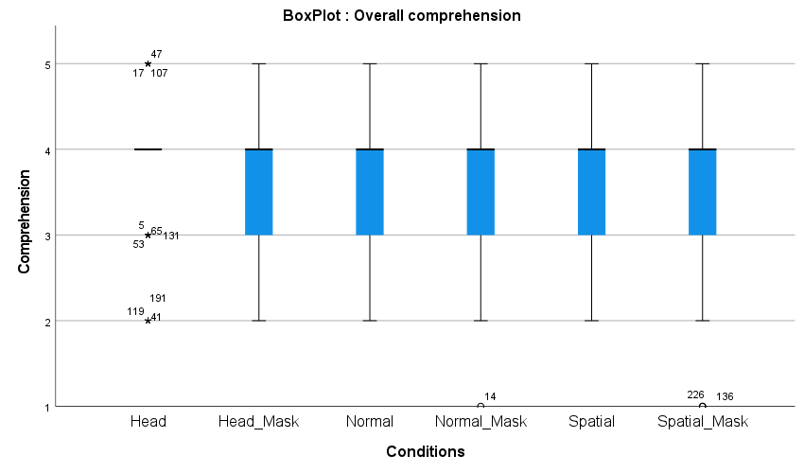

|  |  |  |  |  |  |  |  |
| --- | --- | --- | --- | --- | --- | --- | --- |
| **Statistics** | | | | | | | |
|  | | Normal | Normal_Mask | Spatial | Spatial_Mask | Head | Head_Mask |
| N | Valid | 42 | 42 | 42 | 42 | 42 | 42 |
| Missing | 0 | 0 | 0 | 0 | 0 | 0 |
| Mean | | 3,76 | 3,69 | 3,62 | 3,48 | 3,88 | 3,76 |
| Median | | 4,00 | 4,00 | 4,00 | 4,00 | 4,00 | 4,00 |
| Std. Deviation | | ,759 | 1,000 | 1,011 | 1,110 | ,803 | ,932 |
| Variance | | ,576 | ,999 | 1,022 | 1,231 | ,644 | ,869 |
| Minimum | | 2 | 1 | 2 | 1 | 2 | 2 |
| Maximum | | 5 | 5 | 5 | 5 | 5 | 5 |
| Sum | | 158 | 155 | 152 | 146 | 163 | 158 |
| Percentiles | 25 | 3,00 | 3,00 | 3,00 | 3,00 | 3,75 | 3,00 |
| 50 | 4,00 | 4,00 | 4,00 | 4,00 | 4,00 | 4,00 |
| 75 | 4,00 | 4,00 | 4,00 | 4,00 | 4,00 | 4,00 |

**Frequency Table**

|  |  |  |  |  |  |
| --- | --- | --- | --- | --- | --- |
| **Normal** | | | | | |
|  | | Frequency | Percent | Valid Percent | Cumulative Percent |
| Valid | Bad | 3 | 7,1 | 7,1 | 7,1 |
| Normal | 9 | 21,4 | 21,4 | 28,6 |
| Good | 25 | 59,5 | 59,5 | 88,1 |
| Very good | 5 | 11,9 | 11,9 | 100,0 |
| Total | 42 | 100,0 | 100,0 |  |

|  |  |  |  |  |  |
| --- | --- | --- | --- | --- | --- |
| **Normal_Mask** | | | | | |
|  | | Frequency | Percent | Valid Percent | Cumulative Percent |
| Valid | Very bad | 1 | 2,4 | 2,4 | 2,4 |
| Bad | 4 | 9,5 | 9,5 | 11,9 |
| Normal | 11 | 26,2 | 26,2 | 38,1 |
| Good | 17 | 40,5 | 40,5 | 78,6 |
| Very good | 9 | 21,4 | 21,4 | 100,0 |
| Total | 42 | 100,0 | 100,0 |  |

|  |  |  |  |  |  |
| --- | --- | --- | --- | --- | --- |
| **Spatial** | | | | | |
|  | | Frequency | Percent | Valid Percent | Cumulative Percent |
| Valid | Bad | 7 | 16,7 | 16,7 | 16,7 |
| Normal | 11 | 26,2 | 26,2 | 42,9 |
| Good | 15 | 35,7 | 35,7 | 78,6 |
| Very good | 9 | 21,4 | 21,4 | 100,0 |
| Total | 42 | 100,0 | 100,0 |  |

|  |  |  |  |  |  |
| --- | --- | --- | --- | --- | --- |
| **Spatial_Mask** | | | | | |
|  | | Frequency | Percent | Valid Percent | Cumulative Percent |
| Valid | Very bad | 2 | 4,8 | 4,8 | 4,8 |
| Bad | 7 | 16,7 | 16,7 | 21,4 |
| Normal | 9 | 21,4 | 21,4 | 42,9 |
| Good | 17 | 40,5 | 40,5 | 83,3 |
| Very good | 7 | 16,7 | 16,7 | 100,0 |
| Total | 42 | 100,0 | 100,0 |  |

|  |  |  |  |  |  |
| --- | --- | --- | --- | --- | --- |
| **Head** | | | | | |
|  | | Frequency | Percent | Valid Percent | Cumulative Percent |
| Valid | Bad | 3 | 7,1 | 7,1 | 7,1 |
| Normal | 7 | 16,7 | 16,7 | 23,8 |
| Good | 24 | 57,1 | 57,1 | 81,0 |
| Very good | 8 | 19,0 | 19,0 | 100,0 |
| Total | 42 | 100,0 | 100,0 |  |

|  |  |  |  |  |  |
| --- | --- | --- | --- | --- | --- |
| **Head_Mask** | | | | | |
|  | | Frequency | Percent | Valid Percent | Cumulative Percent |
| Valid | Bad | 5 | 11,9 | 11,9 | 11,9 |
| Normal | 9 | 21,4 | 21,4 | 33,3 |
| Good | 19 | 45,2 | 45,2 | 78,6 |
| Very good | 9 | 21,4 | 21,4 | 100,0 |
| Total | 42 | 100,0 | 100,0 |  |

### Significance tests:

#### No mask vs mask

##### Friedman

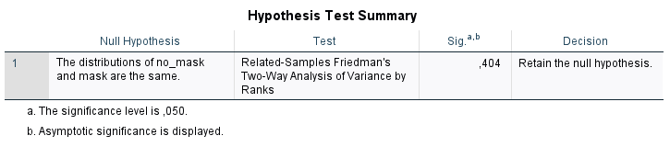

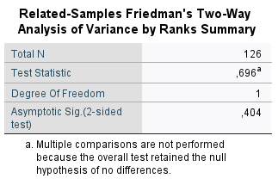

#### No mask

|  |  |  |  |  |  |
| --- | --- | --- | --- | --- | --- |
| **Levene's Test of Equality of Error Variancesa,b** | | | | | |
|  | | Levene Statistic | df1 | df2 | Sig. |
| SubComp | Based on Mean | 4,475 | 2 | 123 | ,013 |
| Based on Median | 3,342 | 2 | 123 | ,039 |
| Based on Median and with adjusted df | 3,342 | 2 | 121,646 | ,039 |
| Based on trimmed mean | 4,706 | 2 | 123 | ,011 |
| Tests the null hypothesis that the error variance of the dependent variable is equal across groups. | | | | | |
| a. Dependent variable: SubComp | | | | | |
| b. Design: Intercept + NoMask | | | | | |

Homogeneous variances: not ok. ANOVA can’t be performed

|  |  |  |  |  |  |  |  |
| --- | --- | --- | --- | --- | --- | --- | --- |
| **Tests of Normality** | | | | | | | |
|  | NoMask | Kolmogorov-Smirnova | | | Shapiro-Wilk | | |
|  | Statistic | df | Sig. | Statistic | df | Sig. |
| SubComp | Head | ,321 | 42 | ,000 | ,822 | 42 | ,000 |
| Normal | ,337 | 42 | ,000 | ,814 | 42 | ,000 |
| Spatial | ,218 | 42 | ,000 | ,876 | 42 | ,000 |
| a. Lilliefors Significance Correction | | | | | | | |

Normal distribution: not ok. ANOVA can’t be performed

|  |  |  |  |  |  |
| --- | --- | --- | --- | --- | --- |
| **ANOVA** | | | | | |
| SubComp | | | | | |
|  | Sum of Squares | df | Mean Square | F | Sig. |
| Between Groups | 1,444 | 2 | ,722 | ,966 | ,383 |
| Within Groups | 91,929 | 123 | ,747 |  |  |
| Total | 93,373 | 125 |  |  |  |

**Kruskal-Wallis:**

|  |  |  |  |  |
| --- | --- | --- | --- | --- |
| **Hypothesis Test Summary** | | | | |
|  | Null Hypothesis | Test | Sig.a,b | Decision |
| 1 | The distribution of SubComp is the same across categories of NoMask. | Independent-Samples Kruskal-Wallis Test | ,430 | Retain the null hypothesis. |
| a. The significance level is ,050. | | | | |
| b. Asymptotic significance is displayed. | | | | |

|  |  |
| --- | --- |
| **Independent-Samples Kruskal-Wallis Test Summary** | |
| Total N | 126 |
| Test Statistic | 1,689a,b |
| Degree Of Freedom | 2 |
| Asymptotic Sig.(2-sided test) | ,430 |
| a. The test statistic is adjusted for ties. | |
| b. Multiple comparisons are not performed because the overall test does not show significant differences across samples. | |

**No statistical difference**

##### Friedman

|  |  |  |  |  |
| --- | --- | --- | --- | --- |
| **Hypothesis Test Summary** | | | | |
|  | Null Hypothesis | Test | Sig.a,b | Decision |
| 1 | The distributions of Normal, Spatial and Head are the same. | Related-Samples Friedman's Two-Way Analysis of Variance by Ranks | ,662 | Retain the null hypothesis. |
| a. The significance level is ,050. | | | | |
| b. Asymptotic significance is displayed. | | | | |

|  |  |
| --- | --- |
| **Related-Samples Friedman's Two-Way Analysis of Variance by Ranks Summary** | |
| Total N | 42 |
| Test Statistic | ,824a |
| Degree Of Freedom | 2 |
| Asymptotic Sig.(2-sided test) | ,662 |
| a. Multiple comparisons are not performed because the overall test retained the null hypothesis of no differences. | |

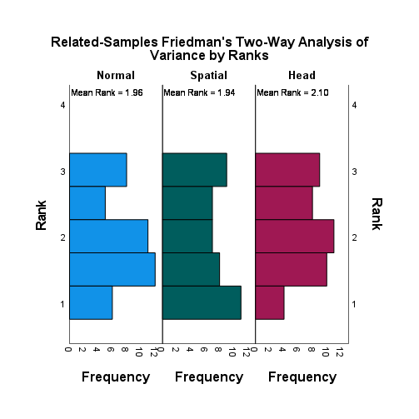

#### Mask

|  |  |  |  |  |  |
| --- | --- | --- | --- | --- | --- |
| **Levene's Test of Equality of Error Variancesa,b** | | | | | |
|  | | Levene Statistic | df1 | df2 | Sig. |
| SubComp | Based on Mean | 1,162 | 2 | 123 | ,316 |
| Based on Median | ,659 | 2 | 123 | ,519 |
| Based on Median and with adjusted df | ,659 | 2 | 117,885 | ,519 |
| Based on trimmed mean | 1,137 | 2 | 123 | ,324 |
| Tests the null hypothesis that the error variance of the dependent variable is equal across groups. | | | | | |
| a. Dependent variable: SubComp | | | | | |
| b. Design: Intercept + Mask | | | | | |

Homogeneous variances : OK.

|  |  |  |  |  |  |  |  |
| --- | --- | --- | --- | --- | --- | --- | --- |
| **Tests of Normality** | | | | | | | |
|  | Mask | Kolmogorov-Smirnova | | | Shapiro-Wilk | | |
|  | Statistic | df | Sig. | Statistic | df | Sig. |
| SubComp | Head | ,267 | 42 | ,000 | ,862 | 42 | ,000 |
| Normal | ,241 | 42 | ,000 | ,886 | 42 | ,001 |
| Spatial | ,253 | 42 | ,000 | ,892 | 42 | ,001 |
| a. Lilliefors Significance Correction | | | | | | | |

Normal distribution: not ok. ANOVA can’t be performed.

|  |  |  |  |  |  |
| --- | --- | --- | --- | --- | --- |
| **ANOVA** | | | | | |
| SubComp | | | | | |
|  | Sum of Squares | df | Mean Square | F | Sig. |
| Between Groups | 1,857 | 2 | ,929 | ,899 | ,410 |
| Within Groups | 127,071 | 123 | 1,033 |  |  |
| Total | 128,929 | 125 |  |  |  |

**Kruskal-Wallis Test:**

|  |  |  |  |  |
| --- | --- | --- | --- | --- |
| **Hypothesis Test Summary** | | | | |
|  | Null Hypothesis | Test | Sig.a,b | Decision |
| 1 | The distribution of SubComp is the same across categories of Mask. | Independent-Samples Kruskal-Wallis Test | ,519 | Retain the null hypothesis. |
| a. The significance level is ,050. | | | | |
| b. Asymptotic significance is displayed. | | | | |

|  |  |
| --- | --- |
| **Independent-Samples Kruskal-Wallis Test Summary** | |
| Total N | 126 |
| Test Statistic | 1,310a,b |
| Degree Of Freedom | 2 |
| Asymptotic Sig.(2-sided test) | ,519 |
| a. The test statistic is adjusted for ties. | |
| b. Multiple comparisons are not performed because the overall test does not show significant differences across samples. | |

**No statistical difference**

##### Friedman

|  |  |  |  |  |
| --- | --- | --- | --- | --- |
| **Hypothesis Test Summary** | | | | |
|  | Null Hypothesis | Test | Sig.a,b | Decision |
| 1 | The distributions of Normal_Mask, Spatial_Mask and Head_Mask are the same. | Related-Samples Friedman's Two-Way Analysis of Variance by Ranks | ,649 | Retain the null hypothesis. |
| a. The significance level is ,050. | | | | |
| b. Asymptotic significance is displayed. | | | | |

|  |  |
| --- | --- |
| **Related-Samples Friedman's Two-Way Analysis of Variance by Ranks Summary** | |
| Total N | 42 |
| Test Statistic | ,864a |
| Degree Of Freedom | 2 |
| Asymptotic Sig.(2-sided test) | ,649 |
| a. Multiple comparisons are not performed because the overall test retained the null hypothesis of no differences. | |

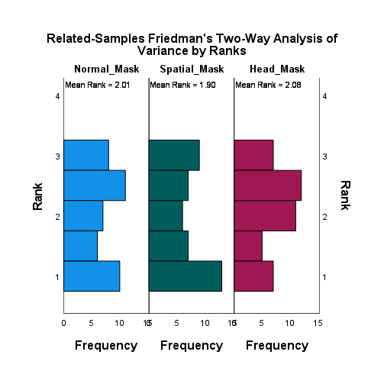

## Post Conference: concentration

How much of your concentration was used to determine who was speaking?

* 1 = very few
* 2 = few
* 3 = normal
* 4 = much
* 5 = very much

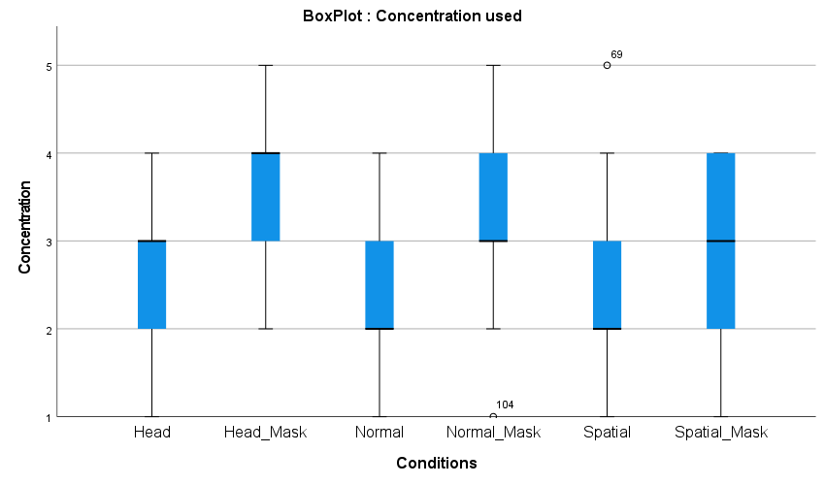

|  |  |  |  |  |  |  |  |
| --- | --- | --- | --- | --- | --- | --- | --- |
| **Statistics** | | | | | | | |
|  | | Normal | Normal_Mask | Spatial | Spatial_Mask | Head | Head_Mask |
| N | Valid | 42 | 42 | 42 | 42 | 42 | 42 |
| Missing | 0 | 0 | 0 | 0 | 0 | 0 |
| Mean | | 2,31 | 3,14 | 2,29 | 3,10 | 2,69 | 3,50 |
| Median | | 2,00 | 3,00 | 2,00 | 3,00 | 3,00 | 4,00 |
| Std. Deviation | | ,897 | ,814 | ,891 | ,906 | 1,000 | ,944 |
| Variance | | ,804 | ,662 | ,794 | ,820 | ,999 | ,890 |
| Minimum | | 1 | 1 | 1 | 1 | 1 | 2 |
| Maximum | | 4 | 5 | 5 | 4 | 4 | 5 |
| Sum | | 97 | 132 | 96 | 130 | 113 | 147 |
| Percentiles | 25 | 2,00 | 3,00 | 2,00 | 2,00 | 2,00 | 3,00 |
| 50 | 2,00 | 3,00 | 2,00 | 3,00 | 3,00 | 4,00 |
| 75 | 3,00 | 4,00 | 3,00 | 4,00 | 3,25 | 4,00 |

**Frequency Table**

|  |  |  |  |  |  |
| --- | --- | --- | --- | --- | --- |
| **Normal** | | | | | |
|  | | Frequency | Percent | Valid Percent | Cumulative Percent |
| Valid | Very few | 9 | 21,4 | 21,4 | 21,4 |
| Few | 14 | 33,3 | 33,3 | 54,8 |
| Normal | 16 | 38,1 | 38,1 | 92,9 |
| Much | 3 | 7,1 | 7,1 | 100,0 |
| Total | 42 | 100,0 | 100,0 |  |

|  |  |  |  |  |  |
| --- | --- | --- | --- | --- | --- |
| **Normal_Mask** | | | | | |
|  | | Frequency | Percent | Valid Percent | Cumulative Percent |
| Valid | Very few | 1 | 2,4 | 2,4 | 2,4 |
| Few | 7 | 16,7 | 16,7 | 19,0 |
| Normal | 20 | 47,6 | 47,6 | 66,7 |
| Much | 13 | 31,0 | 31,0 | 97,6 |
| Very much | 1 | 2,4 | 2,4 | 100,0 |
| Total | 42 | 100,0 | 100,0 |  |

|  |  |  |  |  |  |
| --- | --- | --- | --- | --- | --- |
| **Spatial** | | | | | |
|  | | Frequency | Percent | Valid Percent | Cumulative Percent |
| Valid | Very few | 6 | 14,3 | 14,3 | 14,3 |
| Few | 23 | 54,8 | 54,8 | 69,0 |
| Normal | 9 | 21,4 | 21,4 | 90,5 |
| Much | 3 | 7,1 | 7,1 | 97,6 |
| Very much | 1 | 2,4 | 2,4 | 100,0 |
| Total | 42 | 100,0 | 100,0 |  |

|  |  |  |  |  |  |
| --- | --- | --- | --- | --- | --- |
| **Spatial_Mask** | | | | | |
|  | | Frequency | Percent | Valid Percent | Cumulative Percent |
| Valid | Very few | 2 | 4,8 | 4,8 | 4,8 |
| Few | 9 | 21,4 | 21,4 | 26,2 |
| Normal | 14 | 33,3 | 33,3 | 59,5 |
| Much | 17 | 40,5 | 40,5 | 100,0 |
| Total | 42 | 100,0 | 100,0 |  |

|  |  |  |  |  |  |
| --- | --- | --- | --- | --- | --- |
| **Head** | | | | | |
|  | | Frequency | Percent | Valid Percent | Cumulative Percent |
| Valid | Very few | 6 | 14,3 | 14,3 | 14,3 |
| Few | 11 | 26,2 | 26,2 | 40,5 |
| Normal | 15 | 35,7 | 35,7 | 76,2 |
| Much | 10 | 23,8 | 23,8 | 100,0 |
| Total | 42 | 100,0 | 100,0 |  |

|  |  |  |  |  |  |
| --- | --- | --- | --- | --- | --- |
| **Head_Mask** | | | | | |
|  | | Frequency | Percent | Valid Percent | Cumulative Percent |
| Valid | Few | 7 | 16,7 | 16,7 | 16,7 |
| Normal | 13 | 31,0 | 31,0 | 47,6 |
| Much | 16 | 38,1 | 38,1 | 85,7 |
| Very much | 6 | 14,3 | 14,3 | 100,0 |
| Total | 42 | 100,0 | 100,0 |  |

### Significance tests:

#### No mask vs. Mask SIGNIFICANT

##### Friedman

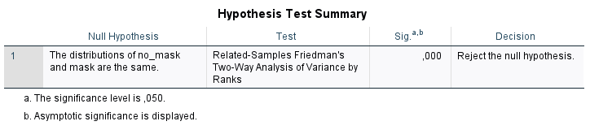

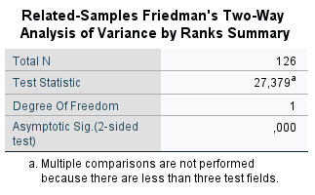

##### Wilcoxon

|  |  |  |  |  |  |
| --- | --- | --- | --- | --- | --- |
| **Descriptive Statistics** | | | | | |
|  | N | Mean | Std. Deviation | Minimum | Maximum |
| Normal | 42 | 2,31 | ,897 | 1 | 4 |
| Spatial | 42 | 2,29 | ,891 | 1 | 5 |
| Head | 42 | 2,69 | 1,000 | 1 | 4 |
| Normal_Mask | 42 | 3,14 | ,814 | 1 | 5 |
| Spatial_Mask | 42 | 3,10 | ,906 | 1 | 4 |
| Head_Mask | 42 | 3,50 | ,944 | 2 | 5 |

|  |  |  |  |  |
| --- | --- | --- | --- | --- |
| **Ranks** | | | | |
|  | | N | Mean Rank | Sum of Ranks |
| Normal_Mask - Normal | Negative Ranks | 6a | 10,83 | 65,00 |
| Positive Ranks | 25b | 17,24 | 431,00 |
| Ties | 11c |  |  |
| Total | 42 |  |  |
| Spatial_Mask - Spatial | Negative Ranks | 9d | 13,67 | 123,00 |
| Positive Ranks | 27e | 20,11 | 543,00 |
| Ties | 6f |  |  |
| Total | 42 |  |  |
| Head_Mask - Head | Negative Ranks | 7g | 9,57 | 67,00 |
| Positive Ranks | 21h | 16,14 | 339,00 |
| Ties | 14i |  |  |
| Total | 42 |  |  |
| a. Normal_Mask < Normal | | | | |
| b. Normal_Mask > Normal | | | | |
| c. Normal_Mask = Normal | | | | |
| d. Spatial_Mask < Spatial | | | | |
| e. Spatial_Mask > Spatial | | | | |
| f. Spatial_Mask = Spatial | | | | |
| g. Head_Mask < Head | | | | |
| h. Head_Mask > Head | | | | |
| i. Head_Mask = Head | | | | |

|  |  |  |  |
| --- | --- | --- | --- |
| **Test Statisticsa** | | | |
|  | Normal_Mask - Normal | Spatial_Mask - Spatial | Head_Mask - Head |
| Z | -3,673b | -3,384b | -3,162b |
| Asymp. Sig. (2-tailed) | ,000 | ,001 | ,002 |
| a. Wilcoxon Signed Ranks Test | | | |
| b. Based on negative ranks. | | | |

**There is an interaction effect between no mask and mask. All auditive formats in the visual condition with mask lead to a higher score of concentration.**

#### No mask

|  |  |  |  |  |  |
| --- | --- | --- | --- | --- | --- |
| **Levene's Test of Equality of Error Variancesa,b** | | | | | |
|  | | Levene Statistic | df1 | df2 | Sig. |
| Concentr | Based on Mean | 1,079 | 2 | 123 | ,343 |
| Based on Median | 1,179 | 2 | 123 | ,311 |
| Based on Median and with adjusted df | 1,179 | 2 | 119,071 | ,311 |
| Based on trimmed mean | 1,235 | 2 | 123 | ,295 |
| Tests the null hypothesis that the error variance of the dependent variable is equal across groups. | | | | | |
| a. Dependent variable: Concentr | | | | | |
| b. Design: Intercept + NoMask | | | | | |

Homogeneous variances : OK.

|  |  |  |  |  |  |  |  |
| --- | --- | --- | --- | --- | --- | --- | --- |
| **Tests of Normality** | | | | | | | |
|  | NoMask | Kolmogorov-Smirnova | | | Shapiro-Wilk | | |
|  | Statistic | df | Sig. | Statistic | df | Sig. |
| Concentr | Head | ,217 | 42 | ,000 | ,874 | 42 | ,000 |
| Normal | ,232 | 42 | ,000 | ,868 | 42 | ,000 |
| Spatial | ,316 | 42 | ,000 | ,838 | 42 | ,000 |
| a. Lilliefors Significance Correction | | | | | | | |

Normal distribution: not ok. ANOVA can’t be performed.

|  |  |  |  |  |  |
| --- | --- | --- | --- | --- | --- |
| **ANOVA** | | | | | |
| Concentration | | | | | |
|  | Sum of Squares | df | Mean Square | F | Sig. |
| Between Groups | 4,333 | 2 | 2,167 | 2,502 | ,086 |
| Within Groups | 106,524 | 123 | ,866 |  |  |
| Total | 110,857 | 125 |  |  |  |

**Kruskal-Wallis Test:**

|  |  |  |  |  |
| --- | --- | --- | --- | --- |
| **Hypothesis Test Summary** | | | | |
|  | Null Hypothesis | Test | Sig.a,b | Decision |
| 1 | The distribution of Concentr is the same across categories of NoMask. | Independent-Samples Kruskal-Wallis Test | ,071 | Retain the null hypothesis. |
| a. The significance level is ,050. | | | | |
| b. Asymptotic significance is displayed. | | | | |

|  |  |
| --- | --- |
| **Independent-Samples Kruskal-Wallis Test Summary** | |
| Total N | 126 |
| Test Statistic | 5,291a,b |
| Degree Of Freedom | 2 |
| Asymptotic Sig.(2-sided test) | ,071 |
| a. The test statistic is adjusted for ties. | |
| b. Multiple comparisons are not performed because the overall test does not show significant differences across samples. | |

**No significant difference.**

##### Friedman SIGNIFICANT

|  |  |  |  |  |
| --- | --- | --- | --- | --- |
| **Hypothesis Test Summary** | | | | |
|  | Null Hypothesis | Test | Sig.a,b | Decision |
| 1 | The distributions of Normal, Spatial and Head are the same. | Related-Samples Friedman's Two-Way Analysis of Variance by Ranks | ,049 | Reject the null hypothesis. |
| a. The significance level is ,050. | | | | |
| b. Asymptotic significance is displayed. | | | | |

|  |  |
| --- | --- |
| **Related-Samples Friedman's Two-Way Analysis of Variance by Ranks Summary** | |
| Total N | 42 |
| Test Statistic | 6,050 |
| Degree Of Freedom | 2 |
| Asymptotic Sig.(2-sided test) | ,049 |

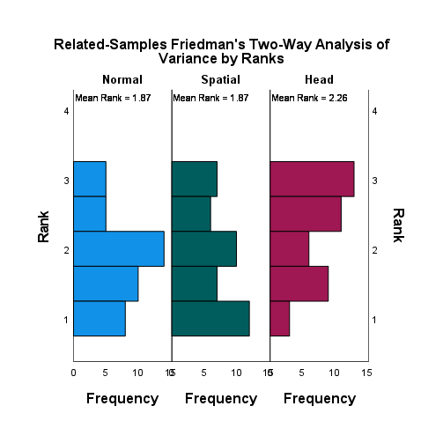

|  |  |  |  |  |  |
| --- | --- | --- | --- | --- | --- |
| **Pairwise Comparisons** | | | | | |
| Sample 1-Sample 2 | Test Statistic | Std. Error | Std. Test Statistic | Sig. | Adj. Sig.a |
| Normal-Spatial | ,000 | ,218 | ,000 | 1,000 | 1,000 |
| Normal-Head | -,393 | ,218 | -1,800 | ,072 | ,215 |
| Spatial-Head | -,393 | ,218 | -1,800 | ,072 | ,215 |
| Each row tests the null hypothesis that the Sample 1 and Sample 2 distributions are the same.  Asymptotic significances (2-sided tests) are displayed. The significance level is ,050. | | | | | |
| a. Significance values have been adjusted by the Bonferroni correction for multiple tests. | | | | | |

|  |  |  |  |  |
| --- | --- | --- | --- | --- |
| **Ranks** | | | | |
|  | | N | Mean Rank | Sum of Ranks |
| Spatial - Normal | Negative Ranks | 17a | 15,82 | 269,00 |
| Positive Ranks | 15b | 17,27 | 259,00 |
| Ties | 10c |  |  |
| Total | 42 |  |  |
| Head - Normal | Negative Ranks | 6d | 13,92 | 83,50 |
| Positive Ranks | 19e | 12,71 | 241,50 |
| Ties | 17f |  |  |
| Total | 42 |  |  |
| Head - Spatial | Negative Ranks | 9g | 12,17 | 109,50 |
| Positive Ranks | 18h | 14,92 | 268,50 |
| Ties | 15i |  |  |
| Total | 42 |  |  |
| a. Spatial < Normal | | | | |
| b. Spatial > Normal | | | | |
| c. Spatial = Normal | | | | |
| d. Head < Normal | | | | |
| e. Head > Normal | | | | |
| f. Head = Normal | | | | |
| g. Head < Spatial | | | | |
| h. Head > Spatial | | | | |
| i. Head = Spatial | | | | |

|  |  |  |  |
| --- | --- | --- | --- |
| **Test Statisticsa** | | | |
|  | Spatial - Normal | Head - Normal | Head - Spatial |
| Z | -,099b | -2,228c | -1,962c |
| Asymp. Sig. (2-tailed) | ,921 | ,026 | ,050 |
| a. Wilcoxon Signed Ranks Test | | | |
| b. Based on positive ranks. | | | |
| c. Based on negative ranks. | | | |

#### Mask

|  |  |  |  |  |  |
| --- | --- | --- | --- | --- | --- |
| **Levene's Test of Equality of Error Variancesa,b** | | | | | |
|  | | Levene Statistic | df1 | df2 | Sig. |
| Concentr | Based on Mean | 1,524 | 2 | 123 | ,222 |
| Based on Median | 1,283 | 2 | 123 | ,281 |
| Based on Median and with adjusted df | 1,283 | 2 | 116,834 | ,281 |
| Based on trimmed mean | 1,507 | 2 | 123 | ,226 |
| Tests the null hypothesis that the error variance of the dependent variable is equal across groups. | | | | | |
| a. Dependent variable: Concentr | | | | | |
| b. Design: Intercept + Mask | | | | | |

Homogeneous variances : OK.

|  |  |  |  |  |  |  |  |
| --- | --- | --- | --- | --- | --- | --- | --- |
| **Tests of Normality** | | | | | | | |
|  | Mask | Kolmogorov-Smirnova | | | Shapiro-Wilk | | |
|  | Statistic | df | Sig. | Statistic | df | Sig. |
| Concentr | Head | ,226 | 42 | ,000 | ,880 | 42 | ,000 |
| Normal | ,240 | 42 | ,000 | ,872 | 42 | ,000 |
| Spatial | ,246 | 42 | ,000 | ,828 | 42 | ,000 |
| a. Lilliefors Significance Correction | | | | | | | |

Normal distribution: not ok. ANOVA can’t be performed.

|  |  |  |  |  |  |
| --- | --- | --- | --- | --- | --- |
| **ANOVA** | | | | | |
| Concentration | | | | | |
|  | Sum of Squares | df | Mean Square | F | Sig. |
| Between Groups | 4,111 | 2 | 2,056 | 2,600 | ,078 |
| Within Groups | 97,262 | 123 | ,791 |  |  |
| Total | 101,373 | 125 |  |  |  |

**Kruskal-Wallis Test:**

|  |  |  |  |  |
| --- | --- | --- | --- | --- |
| **Hypothesis Test Summary** | | | | |
|  | Null Hypothesis | Test | Sig.a,b | Decision |
| 1 | The distribution of Concentr is the same across categories of Mask. | Independent-Samples Kruskal-Wallis Test | ,128 | Retain the null hypothesis. |
| a. The significance level is ,050. | | | | |
| b. Asymptotic significance is displayed. | | | | |

|  |  |
| --- | --- |
| **Independent-Samples Kruskal-Wallis Test Summary** | |
| Total N | 126 |
| Test Statistic | 4,105a,b |
| Degree Of Freedom | 2 |
| Asymptotic Sig.(2-sided test) | ,128 |
| a. The test statistic is adjusted for ties. | |
| b. Multiple comparisons are not performed because the overall test does not show significant differences across samples. | |

**No statistical difference.**

##### Friedman

|  |  |  |  |  |
| --- | --- | --- | --- | --- |
| **Hypothesis Test Summary** | | | | |
|  | Null Hypothesis | Test | Sig.a,b | Decision |
| 1 | The distributions of Normal_Mask, Spatial_Mask and Head_Mask are the same. | Related-Samples Friedman's Two-Way Analysis of Variance by Ranks | ,190 | Retain the null hypothesis. |
| a. The significance level is ,050. | | | | |
| b. Asymptotic significance is displayed. | | | | |

|  |  |
| --- | --- |
| **Related-Samples Friedman's Two-Way Analysis of Variance by Ranks Summary** | |
| Total N | 42 |
| Test Statistic | 3,318a |
| Degree Of Freedom | 2 |
| Asymptotic Sig.(2-sided test) | ,190 |
| a. Multiple comparisons are not performed because the overall test retained the null hypothesis of no differences. | |

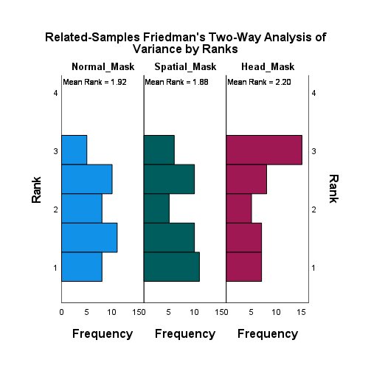

## Post Conference: presence

How present did you felt in that conference?

* 1 = very little present
* 2 = little present
* 3 = normal
* 4 = present
* 5 = very present

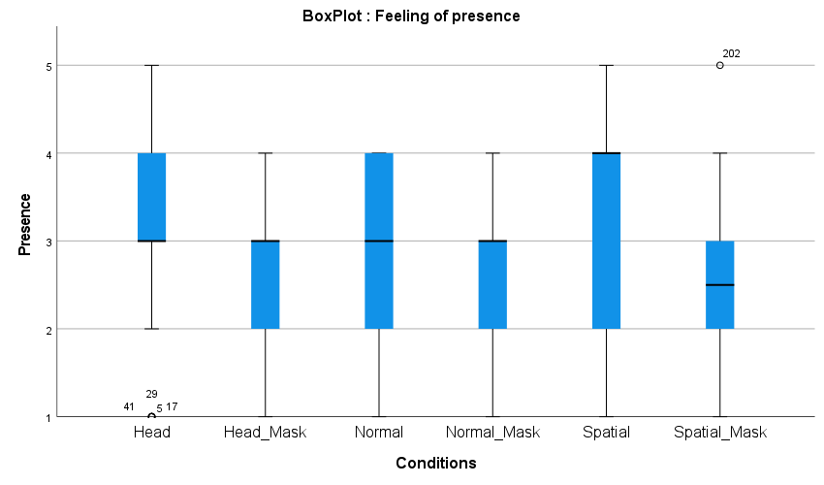

|  |  |  |  |  |  |  |  |
| --- | --- | --- | --- | --- | --- | --- | --- |
| **Statistics** | | | | | | | |
|  | | Normal | Normal_Mask | Spatial | Spatial_Mask | Head | Head_Mask |
| N | Valid | 42 | 42 | 42 | 42 | 42 | 42 |
| Missing | 0 | 0 | 0 | 0 | 0 | 0 |
| Mean | | 3,02 | 2,62 | 3,21 | 2,64 | 3,05 | 2,64 |
| Median | | 3,00 | 3,00 | 4,00 | 2,50 | 3,00 | 3,00 |
| Std. Deviation | | ,975 | 1,011 | 1,159 | 1,032 | 1,058 | ,983 |
| Variance | | ,951 | 1,022 | 1,343 | 1,064 | 1,120 | ,967 |
| Minimum | | 1 | 1 | 1 | 1 | 1 | 1 |
| Maximum | | 4 | 4 | 5 | 5 | 5 | 4 |
| Sum | | 127 | 110 | 135 | 111 | 128 | 111 |
| Percentiles | 25 | 2,00 | 2,00 | 2,00 | 2,00 | 3,00 | 2,00 |
| 50 | 3,00 | 3,00 | 4,00 | 2,50 | 3,00 | 3,00 |
| 75 | 4,00 | 3,25 | 4,00 | 3,25 | 4,00 | 3,25 |

**Frequency Table**

|  |  |  |  |  |  |
| --- | --- | --- | --- | --- | --- |
| **Normal** | | | | | |
|  | | Frequency | Percent | Valid Percent | Cumulative Percent |
| Valid | Very little present | 3 | 7,1 | 7,1 | 7,1 |
| Little present | 10 | 23,8 | 23,8 | 31,0 |
| Normal | 12 | 28,6 | 28,6 | 59,5 |
| Present | 17 | 40,5 | 40,5 | 100,0 |
| Total | 42 | 100,0 | 100,0 |  |

|  |  |  |  |  |  |
| --- | --- | --- | --- | --- | --- |
| **Normal_Mask** | | | | | |
|  | | Frequency | Percent | Valid Percent | Cumulative Percent |
| Valid | Very little present | 6 | 14,3 | 14,3 | 14,3 |
| Little present | 14 | 33,3 | 33,3 | 47,6 |
| Normal | 12 | 28,6 | 28,6 | 76,2 |
| Present | 10 | 23,8 | 23,8 | 100,0 |
| Total | 42 | 100,0 | 100,0 |  |

|  |  |  |  |  |  |
| --- | --- | --- | --- | --- | --- |
| **Spatial** | | | | | |
|  | | Frequency | Percent | Valid Percent | Cumulative Percent |
| Valid | Very little present | 5 | 11,9 | 11,9 | 11,9 |
| Little present | 6 | 14,3 | 14,3 | 26,2 |
| Normal | 9 | 21,4 | 21,4 | 47,6 |
| Present | 19 | 45,2 | 45,2 | 92,9 |
| Very present | 3 | 7,1 | 7,1 | 100,0 |
| Total | 42 | 100,0 | 100,0 |  |

|  |  |  |  |  |  |
| --- | --- | --- | --- | --- | --- |
| **Spatial_Mask** | | | | | |
|  | | Frequency | Percent | Valid Percent | Cumulative Percent |
| Valid | Very little present | 5 | 11,9 | 11,9 | 11,9 |
| Little present | 16 | 38,1 | 38,1 | 50,0 |
| Normal | 11 | 26,2 | 26,2 | 76,2 |
| Present | 9 | 21,4 | 21,4 | 97,6 |
| Very present | 1 | 2,4 | 2,4 | 100,0 |
| Total | 42 | 100,0 | 100,0 |  |

|  |  |  |  |  |  |
| --- | --- | --- | --- | --- | --- |
| **Head** | | | | | |
|  | | Frequency | Percent | Valid Percent | Cumulative Percent |
| Valid | Very little present | 6 | 14,3 | 14,3 | 14,3 |
| Little present | 3 | 7,1 | 7,1 | 21,4 |
| Normal | 17 | 40,5 | 40,5 | 61,9 |
| Present | 15 | 35,7 | 35,7 | 97,6 |
| Very present | 1 | 2,4 | 2,4 | 100,0 |
| Total | 42 | 100,0 | 100,0 |  |

|  |  |  |  |  |  |
| --- | --- | --- | --- | --- | --- |
| **Head_Mask** | | | | | |
|  | | Frequency | Percent | Valid Percent | Cumulative Percent |
| Valid | Very little present | 5 | 11,9 | 11,9 | 11,9 |
| Little present | 15 | 35,7 | 35,7 | 47,6 |
| Normal | 12 | 28,6 | 28,6 | 76,2 |
| Present | 10 | 23,8 | 23,8 | 100,0 |
| Total | 42 | 100,0 | 100,0 |  |

### Significance tests

#### No mask vs. Mask

##### Friedman

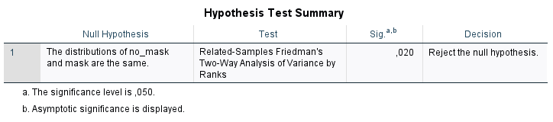

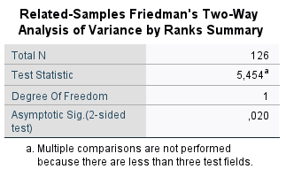

##### Wilcoxon

|  |  |  |  |  |  |
| --- | --- | --- | --- | --- | --- |
| **Descriptive Statistics** | | | | | |
|  | N | Mean | Std. Deviation | Minimum | Maximum |
| Normal | 42 | 3,02 | ,975 | 1 | 4 |
| Spatial | 42 | 3,21 | 1,159 | 1 | 5 |
| Head | 42 | 3,05 | 1,058 | 1 | 5 |
| Normal_Mask | 42 | 2,62 | 1,011 | 1 | 4 |
| Spatial_Mask | 42 | 2,64 | 1,032 | 1 | 5 |
| Head_Mask | 42 | 2,64 | ,983 | 1 | 4 |

|  |  |  |  |  |
| --- | --- | --- | --- | --- |
| **Ranks** | | | | |
|  | | N | Mean Rank | Sum of Ranks |
| Normal_Mask - Normal | Negative Ranks | 20a | 16,80 | 336,00 |
| Positive Ranks | 11b | 14,55 | 160,00 |
| Ties | 11c |  |  |
| Total | 42 |  |  |
| Spatial_Mask - Spatial | Negative Ranks | 22d | 19,55 | 430,00 |
| Positive Ranks | 12e | 13,75 | 165,00 |
| Ties | 8f |  |  |
| Total | 42 |  |  |
| Head_Mask - Head | Negative Ranks | 18g | 20,00 | 360,00 |
| Positive Ranks | 14h | 12,00 | 168,00 |
| Ties | 10i |  |  |
| Total | 42 |  |  |
| a. Normal_Mask < Normal | | | | |
| b. Normal_Mask > Normal | | | | |
| c. Normal_Mask = Normal | | | | |
| d. Spatial_Mask < Spatial | | | | |
| e. Spatial_Mask > Spatial | | | | |
| f. Spatial_Mask = Spatial | | | | |
| g. Head_Mask < Head | | | | |
| h. Head_Mask > Head | | | | |
| i. Head_Mask = Head | | | | |

|  |  |  |  |
| --- | --- | --- | --- |
| **Test Statisticsa** | | | |
|  | Normal_Mask - Normal | Spatial_Mask - Spatial | Head_Mask - Head |
| Z | -1,767b | -2,317b | -1,847b |
| Asymp. Sig. (2-tailed) | ,077 | ,021 | ,065 |
| a. Wilcoxon Signed Ranks Test | | | |
| b. Based on positive ranks. | | | |

There is an interaction effect between no mask and mask. The binaural audio format without head rotation in the visual condition without mask lead to a higher feeling of presence than in the visual condition with mask.

#### No mask

|  |  |  |  |  |  |
| --- | --- | --- | --- | --- | --- |
| **Levene's Test of Equality of Error Variancesa,b** | | | | | |
|  | | Levene Statistic | df1 | df2 | Sig. |
| Presence | Based on Mean | 1,190 | 2 | 123 | ,308 |
| Based on Median | ,528 | 2 | 123 | ,591 |
| Based on Median and with adjusted df | ,528 | 2 | 97,948 | ,591 |
| Based on trimmed mean | 1,080 | 2 | 123 | ,343 |
| Tests the null hypothesis that the error variance of the dependent variable is equal across groups. | | | | | |
| a. Dependent variable: Presence | | | | | |
| b. Design: Intercept + NoMask | | | | | |

Homogeneous variances : OK.

|  |  |  |  |  |  |  |  |
| --- | --- | --- | --- | --- | --- | --- | --- |
| **Tests of Normality** | | | | | | | |
|  | NoMask | Kolmogorov-Smirnova | | | Shapiro-Wilk | | |
|  | Statistic | df | Sig. | Statistic | df | Sig. |
| Presence | Head | ,268 | 42 | ,000 | ,837 | 42 | ,000 |
| Normal | ,246 | 42 | ,000 | ,830 | 42 | ,000 |
| Spatial | ,275 | 42 | ,000 | ,858 | 42 | ,000 |
| a. Lilliefors Significance Correction | | | | | | | |

Normal distribution: Not ok. ANOVA can’t be performed.

|  |  |  |  |  |  |
| --- | --- | --- | --- | --- | --- |
| **ANOVA** | | | | | |
| Presence | | | | | |
|  | Sum of Squares | df | Mean Square | F | Sig. |
| Between Groups | ,905 | 2 | ,452 | ,398 | ,673 |
| Within Groups | 139,952 | 123 | 1,138 |  |  |
| Total | 140,857 | 125 |  |  |  |

**Kruskal-Wallis Test:**

|  |  |  |  |  |
| --- | --- | --- | --- | --- |
| **Hypothesis Test Summary** | | | | |
|  | Null Hypothesis | Test | Sig.a,b | Decision |
| 1 | The distribution of Presence is the same across categories of NoMask. | Independent-Samples Kruskal-Wallis Test | ,535 | Retain the null hypothesis. |
| a. The significance level is ,050. | | | | |
| b. Asymptotic significance is displayed. | | | | |

|  |  |
| --- | --- |
| **Independent-Samples Kruskal-Wallis Test Summary** | |
| Total N | 126 |
| Test Statistic | 1,253a,b |
| Degree Of Freedom | 2 |
| Asymptotic Sig.(2-sided test) | ,535 |
| a. The test statistic is adjusted for ties. | |
| b. Multiple comparisons are not performed because the overall test does not show significant differences across samples. | |

**No significant difference.**

##### Friedman

|  |  |  |  |  |
| --- | --- | --- | --- | --- |
| **Hypothesis Test Summary** | | | | |
|  | Null Hypothesis | Test | Sig.a,b | Decision |
| 1 | The distributions of Normal, Spatial and Head are the same. | Related-Samples Friedman's Two-Way Analysis of Variance by Ranks | ,365 | Retain the null hypothesis. |
| a. The significance level is ,050. | | | | |
| b. Asymptotic significance is displayed. | | | | |

|  |  |
| --- | --- |
| **Related-Samples Friedman's Two-Way Analysis of Variance by Ranks Summary** | |
| Total N | 42 |
| Test Statistic | 2,016a |
| Degree Of Freedom | 2 |
| Asymptotic Sig.(2-sided test) | ,365 |
| a. Multiple comparisons are not performed because the overall test retained the null hypothesis of no differences. | |

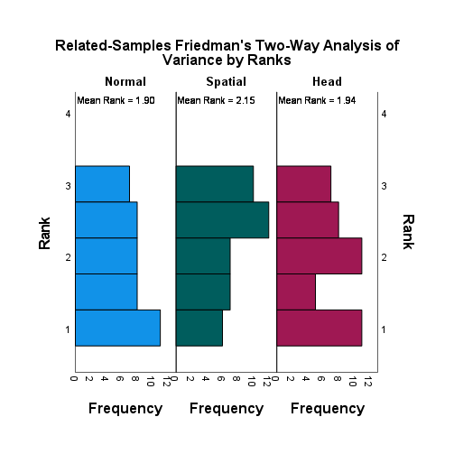

#### Mask

|  |  |  |  |  |  |
| --- | --- | --- | --- | --- | --- |
| **Levene's Test of Equality of Error Variancesa,b** | | | | | |
|  | | Levene Statistic | df1 | df2 | Sig. |
| Presence | Based on Mean | ,046 | 2 | 123 | ,955 |
| Based on Median | ,065 | 2 | 123 | ,937 |
| Based on Median and with adjusted df | ,065 | 2 | 120,336 | ,937 |
| Based on trimmed mean | ,047 | 2 | 123 | ,954 |
| Tests the null hypothesis that the error variance of the dependent variable is equal across groups. | | | | | |
| a. Dependent variable: Presence | | | | | |
| b. Design: Intercept + Mask | | | | | |

Homogeneous variances : OK.

|  |  |  |  |  |  |  |  |
| --- | --- | --- | --- | --- | --- | --- | --- |
| **Tests of Normality** | | | | | | | |
|  | Mask | Kolmogorov-Smirnova | | | Shapiro-Wilk | | |
|  | Statistic | df | Sig. | Statistic | df | Sig. |
| Presence | Head | ,220 | 42 | ,000 | ,873 | 42 | ,000 |
| Normal | ,206 | 42 | ,000 | ,875 | 42 | ,000 |
| Spatial | ,233 | 42 | ,000 | ,898 | 42 | ,001 |
| a. Lilliefors Significance Correction | | | | | | | |

Normal distribution: not ok. ANOVA can’t be performed.

|  |  |  |  |  |  |
| --- | --- | --- | --- | --- | --- |
| **ANOVA** | | | | | |
| Presence | | | | | |
|  | Sum of Squares | df | Mean Square | F | Sig. |
| Between Groups | ,016 | 2 | ,008 | ,008 | ,992 |
| Within Groups | 125,190 | 123 | 1,018 |  |  |
| Total | 125,206 | 125 |  |  |  |

**Kruskal-Wallis Test:**

|  |  |  |  |  |
| --- | --- | --- | --- | --- |
| **Hypothesis Test Summary** | | | | |
|  | Null Hypothesis | Test | Sig.a,b | Decision |
| 1 | The distribution of Presence is the same across categories of Mask. | Independent-Samples Kruskal-Wallis Test | ,995 | Retain the null hypothesis. |
| a. The significance level is ,050. | | | | |
| b. Asymptotic significance is displayed. | | | | |

|  |  |
| --- | --- |
| **Independent-Samples Kruskal-Wallis Test Summary** | |
| Total N | 126 |
| Test Statistic | ,010a,b |
| Degree Of Freedom | 2 |
| Asymptotic Sig.(2-sided test) | ,995 |
| a. The test statistic is adjusted for ties. | |
| b. Multiple comparisons are not performed because the overall test does not show significant differences across samples. | |

**No significant difference.**

##### Friedman

|  |  |  |  |  |
| --- | --- | --- | --- | --- |
| **Hypothesis Test Summary** | | | | |
|  | Null Hypothesis | Test | Sig.a,b | Decision |
| 1 | The distributions of Normal_Mask, Spatial_Mask and Head_Mask are the same. | Related-Samples Friedman's Two-Way Analysis of Variance by Ranks | ,886 | Retain the null hypothesis. |
| a. The significance level is ,050. | | | | |
| b. Asymptotic significance is displayed. | | | | |

|  |  |
| --- | --- |
| **Related-Samples Friedman's Two-Way Analysis of Variance by Ranks Summary** | |
| Total N | 42 |
| Test Statistic | ,242a |
| Degree Of Freedom | 2 |
| Asymptotic Sig.(2-sided test) | ,886 |
| a. Multiple comparisons are not performed because the overall test retained the null hypothesis of no differences. | |

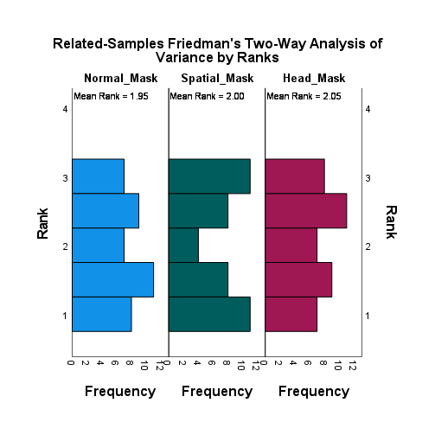

## Post Conference: audio helpfulness

How would you rate the audio you have experienced?

* 1 = very unhelpful
* 2 = unhelpful
* 3 = neutral
* 4 = helpful
* 5 = very helpful

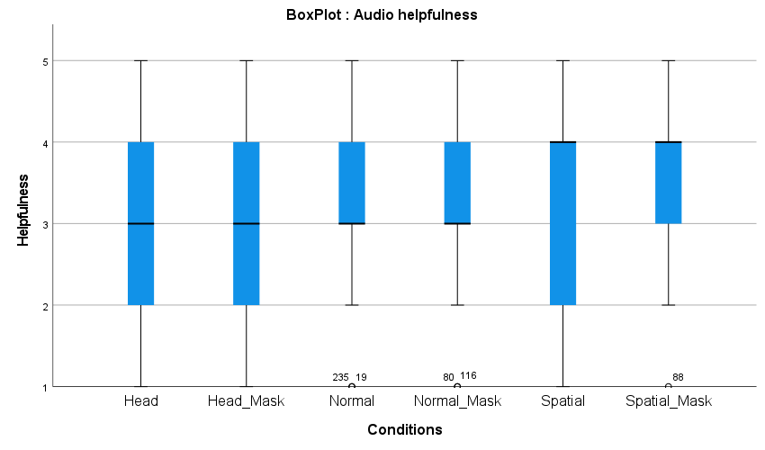

|  |  |  |  |  |  |  |  |
| --- | --- | --- | --- | --- | --- | --- | --- |
| **Statistics** | | | | | | | |
|  | | Normal | Normal_Mask | Spatial | Spatial_Mask | Head | Head_Mask |
| N | Valid | 42 | 42 | 42 | 42 | 42 | 42 |
| Missing | 0 | 0 | 0 | 0 | 0 | 0 |
| Mean | | 3,40 | 3,26 | 3,29 | 3,62 | 2,76 | 2,90 |
| Median | | 3,00 | 3,00 | 4,00 | 4,00 | 3,00 | 3,00 |
| Std. Deviation | | ,939 | ,885 | 1,111 | 1,081 | 1,008 | 1,100 |
| Variance | | ,881 | ,783 | 1,233 | 1,168 | 1,015 | 1,210 |
| Minimum | | 1 | 1 | 1 | 1 | 1 | 1 |
| Maximum | | 5 | 5 | 5 | 5 | 5 | 5 |
| Sum | | 143 | 137 | 138 | 152 | 116 | 122 |
| Percentiles | 25 | 3,00 | 3,00 | 2,00 | 3,00 | 2,00 | 2,00 |
| 50 | 3,00 | 3,00 | 4,00 | 4,00 | 3,00 | 3,00 |
| 75 | 4,00 | 4,00 | 4,00 | 4,00 | 4,00 | 4,00 |

**Frequency Table**

|  |  |  |  |  |  |
| --- | --- | --- | --- | --- | --- |
| **Normal** | | | | | |
|  | | Frequency | Percent | Valid Percent | Cumulative Percent |
| Valid | Very unhelpful | 2 | 4,8 | 4,8 | 4,8 |
| Unhelpful | 3 | 7,1 | 7,1 | 11,9 |
| Neutral | 17 | 40,5 | 40,5 | 52,4 |
| Helpful | 16 | 38,1 | 38,1 | 90,5 |
| Very helpful | 4 | 9,5 | 9,5 | 100,0 |
| Total | 42 | 100,0 | 100,0 |  |

|  |  |  |  |  |  |
| --- | --- | --- | --- | --- | --- |
| **Normal_Mask** | | | | | |
|  | | Frequency | Percent | Valid Percent | Cumulative Percent |
| Valid | Very unhelpful | 2 | 4,8 | 4,8 | 4,8 |
| Unhelpful | 5 | 11,9 | 11,9 | 16,7 |
| Neutral | 16 | 38,1 | 38,1 | 54,8 |
| Helpful | 18 | 42,9 | 42,9 | 97,6 |
| Very helpful | 1 | 2,4 | 2,4 | 100,0 |
| Total | 42 | 100,0 | 100,0 |  |

|  |  |  |  |  |  |
| --- | --- | --- | --- | --- | --- |
| **Spatial** | | | | | |
|  | | Frequency | Percent | Valid Percent | Cumulative Percent |
| Valid | Very unhelpful | 3 | 7,1 | 7,1 | 7,1 |
| Unhelpful | 8 | 19,0 | 19,0 | 26,2 |
| Neutral | 9 | 21,4 | 21,4 | 47,6 |
| Helpful | 18 | 42,9 | 42,9 | 90,5 |
| Very helpful | 4 | 9,5 | 9,5 | 100,0 |
| Total | 42 | 100,0 | 100,0 |  |

|  |  |  |  |  |  |
| --- | --- | --- | --- | --- | --- |
| **Spatial_Mask** | | | | | |
|  | | Frequency | Percent | Valid Percent | Cumulative Percent |
| Valid | Very unhelpful | 1 | 2,4 | 2,4 | 2,4 |
| Unhelpful | 7 | 16,7 | 16,7 | 19,0 |
| Neutral | 8 | 19,0 | 19,0 | 38,1 |
| Helpful | 17 | 40,5 | 40,5 | 78,6 |
| Very helpful | 9 | 21,4 | 21,4 | 100,0 |
| Total | 42 | 100,0 | 100,0 |  |

|  |  |  |  |  |  |
| --- | --- | --- | --- | --- | --- |
| **Head** | | | | | |
|  | | Frequency | Percent | Valid Percent | Cumulative Percent |
| Valid | Very unhelpful | 4 | 9,5 | 9,5 | 9,5 |
| Unhelpful | 14 | 33,3 | 33,3 | 42,9 |
| Neutral | 13 | 31,0 | 31,0 | 73,8 |
| Helpful | 10 | 23,8 | 23,8 | 97,6 |
| Very helpful | 1 | 2,4 | 2,4 | 100,0 |
| Total | 42 | 100,0 | 100,0 |  |

|  |  |  |  |  |  |
| --- | --- | --- | --- | --- | --- |
| **Head_Mask** | | | | | |
|  | | Frequency | Percent | Valid Percent | Cumulative Percent |
| Valid | Very unhelpful | 5 | 11,9 | 11,9 | 11,9 |
| Unhelpful | 10 | 23,8 | 23,8 | 35,7 |
| Neutral | 13 | 31,0 | 31,0 | 66,7 |
| Helpful | 12 | 28,6 | 28,6 | 95,2 |
| Very helpful | 2 | 4,8 | 4,8 | 100,0 |
| Total | 42 | 100,0 | 100,0 |  |

### Significance tests

#### No mask vs. Mask

##### Friedman

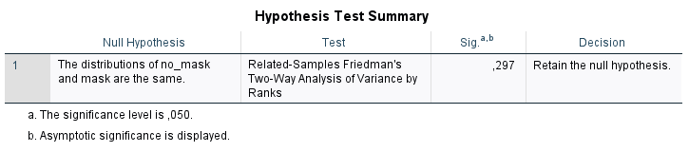

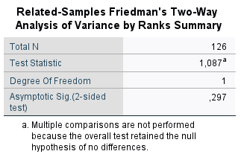

#### No mask

|  |  |  |  |  |  |
| --- | --- | --- | --- | --- | --- |
| **Levene's Test of Equality of Error Variancesa,b** | | | | | |
|  | | Levene Statistic | df1 | df2 | Sig. |
| AudioHelp | Based on Mean | 1,140 | 2 | 123 | ,323 |
| Based on Median | ,487 | 2 | 123 | ,616 |
| Based on Median and with adjusted df | ,487 | 2 | 107,973 | ,616 |
| Based on trimmed mean | 1,092 | 2 | 123 | ,339 |
| Tests the null hypothesis that the error variance of the dependent variable is equal across groups. | | | | | |
| a. Dependent variable: AudioHelp | | | | | |
| b. Design: Intercept + NoMask | | | | | |

Homogeneous variances : OK.

|  |  |  |  |  |  |  |  |
| --- | --- | --- | --- | --- | --- | --- | --- |
| **Tests of Normality** | | | | | | | |
|  | NoMask | Kolmogorov-Smirnova | | | Shapiro-Wilk | | |
|  | Statistic | df | Sig. | Statistic | df | Sig. |
| AudioHelp | Head | ,204 | 42 | ,000 | ,903 | 42 | ,002 |
| Normal | ,214 | 42 | ,000 | ,876 | 42 | ,000 |
| Spatial | ,264 | 42 | ,000 | ,883 | 42 | ,000 |
| a. Lilliefors Significance Correction | | | | | | | |

Normal distribution: Not ok. ANOVA can’t be performed.

|  |  |  |  |  |  |
| --- | --- | --- | --- | --- | --- |
| **ANOVA** | | | | | |
| AudioHelp | | | | | |
|  | Sum of Squares | df | Mean Square | F | Sig. |
| Between Groups | 9,825 | 2 | 4,913 | 4,709 | ,011 |
| Within Groups | 128,310 | 123 | 1,043 |  |  |
| Total | 138,135 | 125 |  |  |  |

* Would have a significant difference with ANOVA.

**Kruskal-Wallis Test**

|  |  |  |  |  |
| --- | --- | --- | --- | --- |
| **Hypothesis Test Summary** | | | | |
|  | Null Hypothesis | Test | Sig.a,b | Decision |
| 1 | The distribution of AudioHelp is the same across categories of NoMask. | Independent-Samples Kruskal-Wallis Test | ,010 | Reject the null hypothesis. |
| a. The significance level is ,050. | | | | |
| b. Asymptotic significance is displayed. | | | | |

|  |  |
| --- | --- |
| **Independent-Samples Kruskal-Wallis Test Summary** | |
| Total N | 126 |
| Test Statistic | 9,291a |
| Degree Of Freedom | 2 |
| Asymptotic Sig.(2-sided test) | ,010 |
| a. The test statistic is adjusted for ties. | |

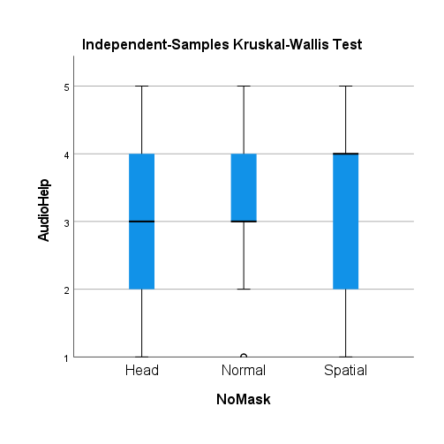

|  |  |  |  |  |  |
| --- | --- | --- | --- | --- | --- |
| **Pairwise Comparisons of NoMask** | | | | | |
| Sample 1-Sample 2 | Test Statistic | Std. Error | Std. Test Statistic | Sig. | Adj. Sig.a |
| Head-Spatial | -18,500 | 7,640 | -2,421 | ,015 | ,046 |
| Head-Normal | -21,500 | 7,640 | -2,814 | ,005 | ,015 |
| Spatial-Normal | 3,000 | 7,640 | ,393 | ,695 | 1,000 |
| Each row tests the null hypothesis that the Sample 1 and Sample 2 distributions are the same.  Asymptotic significances (2-sided tests) are displayed. The significance level is ,050. | | | | | |
| a. Significance values have been adjusted by the Bonferroni correction for multiple tests. | | | | | |

There is a significant difference between Head and the other conditions, without masks. Head lead to the most unhelpful subjective ranking.

##### Friedman SIGNIFICANT

|  |  |  |  |  |
| --- | --- | --- | --- | --- |
| **Hypothesis Test Summary** | | | | |
|  | Null Hypothesis | Test | Sig.a,b | Decision |
| 1 | The distributions of Normal, Spatial and Head are the same. | Related-Samples Friedman's Two-Way Analysis of Variance by Ranks | ,013 | Reject the null hypothesis. |
| a. The significance level is ,050. | | | | |
| b. Asymptotic significance is displayed. | | | | |

|  |  |
| --- | --- |
| **Related-Samples Friedman's Two-Way Analysis of Variance by Ranks Summary** | |
| Total N | 42 |
| Test Statistic | 8,715 |
| Degree Of Freedom | 2 |
| Asymptotic Sig.(2-sided test) | ,013 |

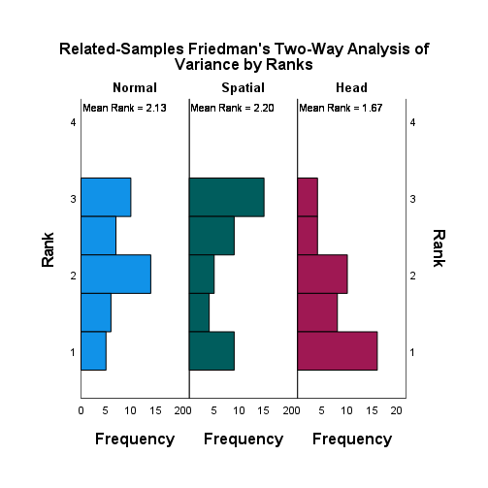

|  |  |  |  |  |  |
| --- | --- | --- | --- | --- | --- |
| **Pairwise Comparisons** | | | | | |
| Sample 1-Sample 2 | Test Statistic | Std. Error | Std. Test Statistic | Sig. | Adj. Sig.a |
| Head-Normal | ,464 | ,218 | 2,128 | ,033 | ,100 |
| Head-Spatial | ,536 | ,218 | 2,455 | ,014 | ,042 |
| Normal-Spatial | -,071 | ,218 | -,327 | ,743 | 1,000 |
| Each row tests the null hypothesis that the Sample 1 and Sample 2 distributions are the same.  Asymptotic significances (2-sided tests) are displayed. The significance level is ,050. | | | | | |
| a. Significance values have been adjusted by the Bonferroni correction for multiple tests. | | | | | |

|  |  |  |  |  |
| --- | --- | --- | --- | --- |
| **Ranks** | | | | |
|  | | N | Mean Rank | Sum of Ranks |
| Spatial - Normal | Negative Ranks | 14a | 20,39 | 285,50 |
| Positive Ranks | 18b | 13,47 | 242,50 |
| Ties | 10c |  |  |
| Total | 42 |  |  |
| Head - Normal | Negative Ranks | 24d | 18,33 | 440,00 |
| Positive Ranks | 9e | 13,44 | 121,00 |
| Ties | 9f |  |  |
| Total | 42 |  |  |
| Head - Spatial | Negative Ranks | 23g | 17,41 | 400,50 |
| Positive Ranks | 10h | 16,05 | 160,50 |
| Ties | 9i |  |  |
| Total | 42 |  |  |
| a. Spatial < Normal | | | | |
| b. Spatial > Normal | | | | |
| c. Spatial = Normal | | | | |
| d. Head < Normal | | | | |
| e. Head > Normal | | | | |
| f. Head = Normal | | | | |
| g. Head < Spatial | | | | |
| h. Head > Spatial | | | | |
| i. Head = Spatial | | | | |

|  |  |  |  |
| --- | --- | --- | --- |
| **Test Statisticsa** | | | |
|  | Spatial - Normal | Head - Normal | Head - Spatial |
| Z | -,417b | -2,935b | -2,194b |
| Asymp. Sig. (2-tailed) | ,677 | ,003 | ,028 |
| a. Wilcoxon Signed Ranks Test | | | |
| b. Based on positive ranks. | | | |

#### Mask

|  |  |  |  |  |  |
| --- | --- | --- | --- | --- | --- |
| **Levene's Test of Equality of Error Variancesa,b** | | | | | |
|  | | Levene Statistic | df1 | df2 | Sig. |
| AudioHelp | Based on Mean | 1,313 | 2 | 123 | ,273 |
| Based on Median | ,628 | 2 | 123 | ,535 |
| Based on Median and with adjusted df | ,628 | 2 | 116,544 | ,535 |
| Based on trimmed mean | 1,166 | 2 | 123 | ,315 |
| Tests the null hypothesis that the error variance of the dependent variable is equal across groups. | | | | | |
| a. Dependent variable: AudioHelp | | | | | |
| b. Design: Intercept + Mask | | | | | |

Homogeneous variance : OK.

|  |  |  |  |  |  |  |  |
| --- | --- | --- | --- | --- | --- | --- | --- |
| **Tests of Normality** | | | | | | | |
|  | Mask | Kolmogorov-Smirnova | | | Shapiro-Wilk | | |
|  | Statistic | df | Sig. | Statistic | df | Sig. |
| AudioHelp | Head | ,177 | 42 | ,002 | ,910 | 42 | ,003 |
| Normal | ,250 | 42 | ,000 | ,846 | 42 | ,000 |
| Spatial | ,257 | 42 | ,000 | ,881 | 42 | ,000 |
| a. Lilliefors Significance Correction | | | | | | | |

Normal distribution: Not ok. ANOVA can’t be performed.

|  |  |  |  |  |  |
| --- | --- | --- | --- | --- | --- |
| **ANOVA** | | | | | |
| AudioHelp | | | | | |
|  | Sum of Squares | df | Mean Square | F | Sig. |
| Between Groups | 10,714 | 2 | 5,357 | 5,083 | ,008 |
| Within Groups | 129,643 | 123 | 1,054 |  |  |
| Total | 140,357 | 125 |  |  |  |

* Would have a significant difference with ANOVA

**Kruskal-Wallis Test:**

|  |  |  |  |  |
| --- | --- | --- | --- | --- |
| **Hypothesis Test Summary** | | | | |
|  | Null Hypothesis | Test | Sig.a,b | Decision |
| 1 | The distribution of AudioHelp is the same across categories of Mask. | Independent-Samples Kruskal-Wallis Test | ,010 | Reject the null hypothesis. |
| a. The significance level is ,050. | | | | |
| b. Asymptotic significance is displayed. | | | | |

|  |  |
| --- | --- |
| **Independent-Samples Kruskal-Wallis Test Summary** | |
| Total N | 126 |
| Test Statistic | 9,308a |
| Degree Of Freedom | 2 |
| Asymptotic Sig.(2-sided test) | ,010 |
| a. The test statistic is adjusted for ties. | |

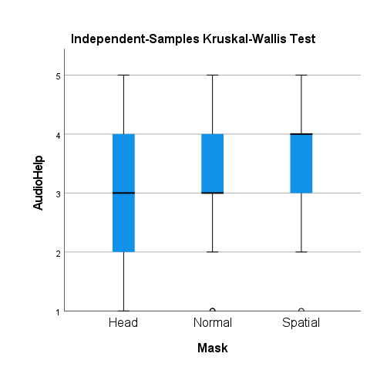

|  |  |  |  |  |  |
| --- | --- | --- | --- | --- | --- |
| **Pairwise Comparisons of Mask** | | | | | |
| Sample 1-Sample 2 | Test Statistic | Std. Error | Std. Test Statistic | Sig. | Adj. Sig.a |
| Head-Normal | -10,988 | 7,628 | -1,440 | ,150 | ,449 |
| Head-Spatial | -23,262 | 7,628 | -3,049 | ,002 | ,007 |
| Normal-Spatial | -12,274 | 7,628 | -1,609 | ,108 | ,323 |
| Each row tests the null hypothesis that the Sample 1 and Sample 2 distributions are the same.  Asymptotic significances (2-sided tests) are displayed. The significance level is ,050. | | | | | |
| a. Significance values have been adjusted by the Bonferroni correction for multiple tests. | | | | | |

**There is a significant difference between Head and Spatial, with mask. When comparing these two conditions, spatial lead to the most helpful audio.**

##### Friedman SIGNIFICANT

|  |  |  |  |  |
| --- | --- | --- | --- | --- |
| **Hypothesis Test Summary** | | | | |
|  | Null Hypothesis | Test | Sig.a,b | Decision |
| 1 | The distributions of Normal_Mask, Spatial_Mask and Head_Mask are the same. | Related-Samples Friedman's Two-Way Analysis of Variance by Ranks | ,013 | Reject the null hypothesis. |
| a. The significance level is ,050. | | | | |
| b. Asymptotic significance is displayed. | | | | |

|  |  |
| --- | --- |
| **Related-Samples Friedman's Two-Way Analysis of Variance by Ranks Summary** | |
| Total N | 42 |
| Test Statistic | 8,676 |
| Degree Of Freedom | 2 |
| Asymptotic Sig.(2-sided test) | ,013 |

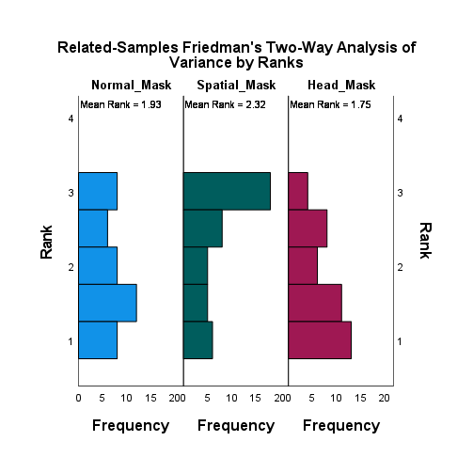

|  |  |  |  |  |  |
| --- | --- | --- | --- | --- | --- |
| **Pairwise Comparisons** | | | | | |
| Sample 1-Sample 2 | Test Statistic | Std. Error | Std. Test Statistic | Sig. | Adj. Sig.a |
| Head_Mask-Normal_Mask | ,179 | ,218 | ,818 | ,413 | 1,000 |
| Head_Mask-Spatial_Mask | ,571 | ,218 | 2,619 | ,009 | ,026 |
| Normal_Mask-Spatial_Mask | -,393 | ,218 | -1,800 | ,072 | ,215 |
| Each row tests the null hypothesis that the Sample 1 and Sample 2 distributions are the same.  Asymptotic significances (2-sided tests) are displayed. The significance level is ,050. | | | | | |
| a. Significance values have been adjusted by the Bonferroni correction for multiple tests. | | | | | |

|  |  |  |  |  |
| --- | --- | --- | --- | --- |
| **Ranks** | | | | |
|  | | N | Mean Rank | Sum of Ranks |
| Spatial_Mask - Normal_Mask | Negative Ranks | 11a | 20,45 | 225,00 |
| Positive Ranks | 24b | 16,88 | 405,00 |
| Ties | 7c |  |  |
| Total | 42 |  |  |
| Head_Mask - Normal_Mask | Negative Ranks | 18d | 16,42 | 295,50 |
| Positive Ranks | 11e | 12,68 | 139,50 |
| Ties | 13f |  |  |
| Total | 42 |  |  |
| Head_Mask - Spatial_Mask | Negative Ranks | 24g | 18,54 | 445,00 |
| Positive Ranks | 10h | 15,00 | 150,00 |
| Ties | 8i |  |  |
| Total | 42 |  |  |
| a. Spatial_Mask < Normal_Mask | | | | |
| b. Spatial_Mask > Normal_Mask | | | | |
| c. Spatial_Mask = Normal_Mask | | | | |
| d. Head_Mask < Normal_Mask | | | | |
| e. Head_Mask > Normal_Mask | | | | |
| f. Head_Mask = Normal_Mask | | | | |
| g. Head_Mask < Spatial_Mask | | | | |
| h. Head_Mask > Spatial_Mask | | | | |
| i. Head_Mask = Spatial_Mask | | | | |

|  |  |  |  |
| --- | --- | --- | --- |
| **Test Statisticsa** | | | |
|  | Spatial_Mask - Normal_Mask | Head_Mask - Normal_Mask | Head_Mask - Spatial_Mask |
| Z | -1,520b | -1,724c | -2,566c |
| Asymp. Sig. (2-tailed) | ,129 | ,085 | ,010 |
| a. Wilcoxon Signed Ranks Test | | | |
| b. Based on negative ranks. | | | |
| c. Based on positive ranks. | | | |

## Final Questionnaire: Strategy to remember who said what

Did you have a strategy to remember who said what?

|  |  |
| --- | --- |
| 1 | J'ai eu beaucoup de mal à me souvenir qui a dit quoi. J'ai essayé avec quelle oreille j'ai écouté l'information s'il y avait de l'audio 3D mais sinon je n'ai pas vraiment trouvé une technique pour me souvenir de qui disait quoi. |
| 2 | Non |
| 3 | Non |
| 4 | Oui ! Faire des acronymes pour chaque personnage et ses idées. |
| 5 | Je me focalisais sur les couleurs des habits des personnes qui parlait et leur place dans la pièce. |
| 6 | Prêter attention à qui prononçait quel message  essayer de construire un déroulement mental de la conversation   C'était plus ou moins facile selon les sujets (ex : salle de bain : bois = droite, pierre = gauche, 3D = milieu), mais pour d'autre sujet plus vague. Peut-être selon les longueurs des phrases et/ou les gestes effectués. |
| 7 | Pas vraiment...je regardais les vêtements et qui était assise où |
| 8 | Je répétais certaines informations au fur et à mesure |
| 9 | Je visualisais ce qui avait été dit par qui en me souvenant des points importants de chacun. (Par exemple pour qui parlait de quelles chansons, je savais qu'il y en avait 6 donc je mettais les mots-clés début, fin et milieu sur chaque personne) ... |
| 10 | Non, au visuelle plutôt gauche, centre, droite |
| 11 | Non, je comptais sur ma mémoire visuelle. |
| 12 | Non pas trop |
| 13 | Je retenais bien qui était positionné dans l'espace. |
| 14 | Je me suis focalisée sur la couleur du pull de chaque intervenante, et ai ensuite essayé d'associer les paroles à ces couleurs pour mieux m'en souvenir. |
| 15 | Avec les écouteurs, j'entends si ça vient de la gauche ou de la droite. Mais ce n’était pas toujours le cas. |
| 16 | Je retenais les positions gauches, centre et droite |
| 17 | Associer les points clés aux personnes après avoir compris la structure des vidéos, ou associer ces points par gauche, droite, milieu. |
| 18 | J'essayais de me rappeler de la position des trois intervenants et je faisais travailler ma mémoire pour savoir d'où venait la phrase demandée. |
| 19 | J’essayais de stéréotyper les personnes et définir leur caractère suivant ce qu'elles disaient |
| 20 | Non |
| 21 | Oui, j'utilisais un système de "fille de gauche, fille du centre, fille du milieu", et j'essayais de mémoriser des mots-clés à chacune de leurs interventions respectives. |
| 22 | J'utilisais la couleur de leur vêtements (blancs, noirs et colorés) afin de me souvenir quelle personne avait proposé telle idée ou posé telle question. |
| 23 | Regarder la personne qui parle et se rappeler quel rôle elle avait dans la conversation. |
| 24 | Je me remémorais la personne qui parlait |
| 25 | J'essayais au maximum d'associer l'apparence physique aux mots (notamment les coupes de cheveux). |
| 26 | L'emplacement des gens, se souvenir 1-2 détails par personne. |
| 27 | Les habits et la voix |
| 28 | Je leur ai donnée des surnoms- machine chignon, machine et Coline |
| 29 | Les discussions avaient des structures similaires. Au fil des vidéos, j'avais quelques "rôles" ou "phrases-types" que je pouvais attribuer à certaines personnes. |
| 30 | Il y avait toujours une personne qui commençait avec l'idée puis une autre qui donnait son avis et la dernière qui ne savait pas grand-chose et qui posait des questions. Donc j'essayais de retenir cet ordre. |
| 31 | Faire une sorte de carte mentale avec les points énoncés sous chaque personne |
| 32 | Non pas spécialement. |
| 33 | Retenir un ou deux mots clés cités par personne, combiné au timbre de voix, pour se refaire la discussion dans la tête par la suite. |
| 34 | Non pas spécialement. Je me focalise essentiellement sur l'écoute et les voix... Le fait de "voir" la vidéoconférence m'a été complétement indifférent. |
| 35 | Je connais les personnes qui sont sur cette vidéo, il était donc plus facile pour moi de les reconnaître. |
| 36 | J'essayais de ranger les infos en trois cases : Gauche, centre, droite |
| 37 | Non aucune, juste une bonne mémoire. |
| 38 | J'essayais de remarquer laquelle donnait les infos, laquelle recadrait le débat et laquelle posait les questions. |
| 39 | Surtout utiliser la mémoire visuelle, où chacune des filles étaient assises dans la salle. |
| 40 | La fille habillée en coloré était plus facilement repérable par rapport à sa place et donc à ce qu'elle disait car en gros j'essayais surtout de me souvenir de quel côté de l'écran venaient les informations pour ensuite les assimiler à une personne. |
| 41 | En fonction de qui était ou |
| 42 | Oui Reconnaître qui était "l'hôte" de la réunion Faire attention aux couleurs des habits |

## Final questionnaire: Spatial audio awareness

Did you heard that the audio was spatialized in some videos? If yes, in how many?

Correct answer is: Yes, in 4 videos.

|  |  |
| --- | --- |
| 1 | oui 3-4, surtout les dernières |
| 2 | 2-3 |
| 3 | Oui dans la plupart d'entre elles (3-4) |
| 4 | Oui, il me semble au moins dans 3 vidéos |
| 5 | oui j'ai remarqué je dirais dans 3 vidéos ou 4 |
| 6 | oui. 3 |
| 7 | je ne sais pas ce que ça veut dire (si c'est en rapport avec un seul écouteur allumé, il y en avait 2) |
| 8 | Dans 4/5 |
| 9 | Oui dans 4 vidéos il me semble. |
| 10 | oui dans 2 ou 3 |
| 11 | Oui, 4 |
| 12 | Dans 3 vidéos |
| 13 | Oui, dans 3 vidéos |
| 14 | 3 vidéos |
| 15 | dans 4 vidéos |
| 16 | Oui, dans 3 vidéos il me semble |
| 17 | 4 il me semble |
| 18 | oui mais je n'arriverai pas à dire combien précisément. J'ai le vague souvenir de 2 vidéos qui étaient particulièrement dures à suivre à cause du son. |
| 19 | oui, je dirai 3 ou 4 |
| 20 | Oui j'aurais dis 2 vidéos |
| 21 | Oui, je dirais dans 3 vidéos. |
| 22 | J'ai remarqué qu'il était spatialisé dans en tout cas 3 vidéos, mais je ne me souviens plus du nombre exact. |
| 23 | Oui, dans 4 vidéos |
| 24 | Dans pratiquement toutes, seule la première n'avait pas le son spatialisé il me semble |
| 25 | Oui. Je ne pourrais pas dire exactement combien... Je dirais plus de la moitié (4-5?). |
| 26 | Environ 3 |
| 27 | Oui, mais je n'ai pas tant fait attention que ça donc je n'arriverais pas dire dans combien de vidéos... Peut-être 2? |
| 28 | oui presque toutes |
| 29 | Oui mais je ne saurais dire dans combien car je me suis rapidement concentré plus sur le contenu des discussions. |
| 30 | Dans 2 ou 3 vidéos je crois |
| 31 | 3 |
| 32 | Oui, je ne suis pas sûr, je dirais 3 vidéos. |
| 33 | Je n'ai pas compté, ~4 je dirais. Parfois correctement, parfois de manière erronée. J'ai surtout détecté 2x (ou 3x) où le son ne semblait pas spatialisé correctement. |
| 34 | Toutes, sauf la dernière |
| 35 | oui, dans 3 ou 4 |
| 36 | oui dans en tout cas 4 vidéos |
| 37 | Oui, dans presque toutes les vidéos |
| 38 | Non |
| 39 | Oui, je dirais peut-être 3 |
| 40 | oui et ceci rendaient la compréhension plus facile. Je dirai dans 3 vidéos ? |
| 41 | oui, dans la moitié des vidéos |
| 42 | oui, dans plus de la moitié |

## Final questionnaire: Spatial audio helpfulness

Did the spatial audio help?

* 1 = Very unhelpful
* 2 = Unhelpful
* 3 = No difference
* 4 = Helpful
* 5 = Very helpful

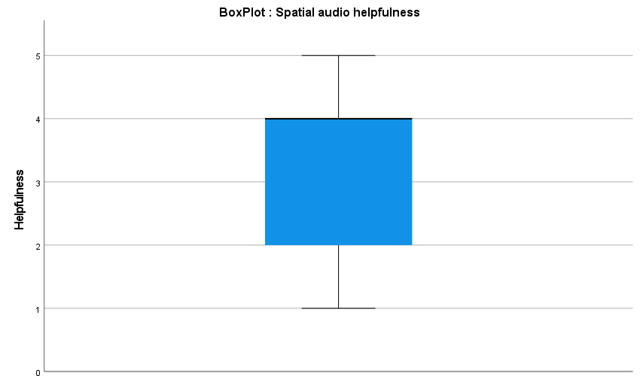

|  |  |  |
| --- | --- | --- |
| **Statistics** | | |
| Helpfulness | | |
| N | Valid | 42 |
| Missing | 0 |
| Mean | | 3,24 |
| Median | | 4,00 |
| Std. Deviation | | 1,226 |
| Variance | | 1,503 |
| Minimum | | 1 |
| Maximum | | 5 |
| Sum | | 136 |
| Percentiles | 25 | 2,00 |
| 50 | 4,00 |
| 75 | 4,00 |

|  |  |  |  |  |  |
| --- | --- | --- | --- | --- | --- |
| **Helpfulness** | | | | | |
|  | | Frequency | Percent | Valid Percent | Cumulative Percent |
| Valid | Very unhelpful | 3 | 7,1 | 7,1 | 7,1 |
| Unhelpful | 12 | 28,6 | 28,6 | 35,7 |
| No difference | 5 | 11,9 | 11,9 | 47,6 |
| Helpful | 16 | 38,1 | 38,1 | 85,7 |
| Very helpful | 6 | 14,3 | 14,3 | 100,0 |
| Total | 42 | 100,0 | 100,0 |  |

## Final questionnaire : Distraction of spatial audio

Was the spatial audio distractive?

* 0 = No
* 1 = Yes

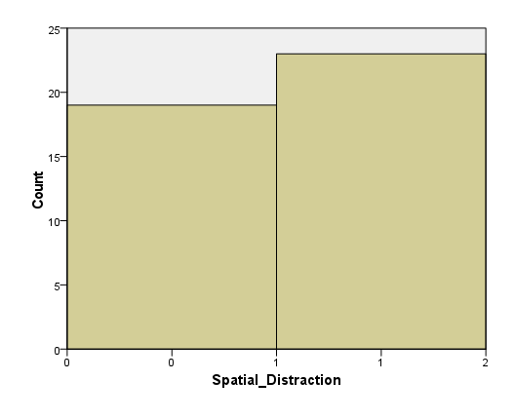

|  |  |  |
| --- | --- | --- |
| **Statistics** | | |
| Spatial_Distraction | | |
| N | Valid | 42 |
| Missing | 0 |
| Mean | | ,55 |
| Median | | 1,00 |
| Std. Deviation | | ,504 |
| Variance | | ,254 |
| Minimum | | 0 |
| Maximum | | 1 |
| Sum | | 23 |
| Percentiles | 25 | ,00 |
| 50 | 1,00 |
| 75 | 1,00 |

|  |  |  |  |  |  |
| --- | --- | --- | --- | --- | --- |
| **Spatial_Distraction** | | | | | |
|  | | Frequency | Percent | Valid Percent | Cumulative Percent |
| Valid | No | 19 | 45,2 | 45,2 | 45,2 |
| Yes | 23 | 54,8 | 54,8 | 100,0 |
| Total | 42 | 100,0 | 100,0 |  |

## Final questionnaire: Feedback/Comments

|  |
| --- |
| Le son spatial était perturbant car mes yeux se dirigeaient sur l'endroit où j'entendais le son.  Quand il y avait des sons perturbateurs, cela a aussi affecté l'endroit où je regardais la vidéo. |
| La première vidéo à son spatialisée était difficile à suivre. Dans les autres vidéos, le son spatialisé était utile (pour localiser la personne qui parle), mais peut-être fatigant. |
| Par rapport à la compréhension :  comprendre le contenu global de la vidéo était indépendant du son, mais une partie de la compréhension a pu être perdue par la recherche de savoir qui parlait pour accomplir la tâche demandée. |
| - Je n’ai pas trop aimé que les intervenantes changent de place (réponses aux questions : qui est la 1, la 2, la 3 cette fois) --> peu baisé  - Je pense que j'ai été meilleure sur la fin parce que ma technique d'écoute s'est améliorée : je savais comment réfléchir et quel type d'informations étaient demandées --> autre biais - Peut-être aurait-il fallu ne pas (toujours ?) attribuer 2 phrases par intervenante. On pouvait fonctionner par déduction si on ne savait pas. De plus, la structure était toujours un peu la même : une dit une idée, la deuxième en a une autre, la troisième en a pas, quelqu'un dit que chose, etc. On peut facilement faire des calculs parce qu'on s'attend à qui va prendre la parole la prochaine fois et il est facile de se refaire le film ensuite. - Même si le type de discussion variait peu, certaines m'ont semblé plus simples que d'autres (album, salle de bain) |
| C'est très perturbant le son spatialisé. J'arrivais à savoir qui parlait simplement au son de la voix à partir de la deuxième vidéo mais le son spatialisé nous distrait de la compréhension et on se perd dans la vidéo. |
| Son spatialisé aidait quand il y avait les masques |
| J'ai trouvé que dans les vidéos avec le son spatialisé, il faudrait que ce soit constamment spatialisé et pas que ça change brusquement d'écouteur lorsqu’on ne change de personne qui parle. |
| Au début, le son spatial m'a perturbé. Pour la première vidéo, je n'ai presque pas fait attention au contenu. Ensuite, le son spatial m'a aidé mais inconsciemment. |
| La première série de question était compliquée j'ai trouvé car on ne sait pas vraiment ce qui nous sera demandé après la vidéo. On essaye d'être attentif sans vraiment savoir à quoi s'attendre. Dans d'autres séries de questions, j'ai été surpris par certaines questions qui paraissaient assez précises et ça m'a un peu déstabilisé car je ne savais plus qui avait dit quoi. |
| Parfois quand plusieurs personnes parlaient en même temps c'était compliqué de comprendre qui parlait avec le son spatial |
| J'ai trouvé que même si le son spatialisé aidait un peu à savoir qui parlait, cela m'a distrait car je n'ai pas l'habitude |
| Il m'a fallu une vidéo pour comprendre tout ce qu'on attendait de moi, et pour mettre une stratégie de compréhension en place. Le port du masque rend la compréhension vraiment plus difficile. Les vidéos avec le son spatialisé aidaient la plupart du temps, mais quelquefois ça me perturbait... |
| Ayant pas mal de soucis de concentration, j'ai parfois rencontré quelques difficultés à me souvenir de qui disait quoi. Dans l'ensemble, le son des vidéos était très bon et la spatialisation du son ne changeait pas grand-chose, elle aidait quand elle était précisément sur la personne qui parlait, mais ne changeait pas trop la situation quand elle était moins précise. |
| De manière générale, comprendre le contenu des vidéos allaient bien, c'était remettre qui avait dit quoi qui était plus compliqué. |
| Je crois la première vidéo avait un son normal et constant. C'était moins perturbant que le switch entre gauche et droite. |
| J'ai l'impression que le son spatialisé ne m'a pas tant distrait/aidé que cela car je pouvais facilement voir les intervenantes et remarquer quand elles prenaient la parole. Dans un cas avec plus de personnes, cela m'aurait peut-être rendu un plus grand service. |
| Je suppose que cela été fait exprès mais une comédienne regardait souvent la caméra et rigolait du coup elle pouvait me distraire. |
| La dernière question sur l'utilité de l'audio n'est pas très claire. |
| - Durant la première vidéo je me suis complètement focalisé sur le fait que mon regard était tracké, et donc je n'ai pas vraiment écouté la discussion. J'ai moi-même étudié mon comportement au niveau de mon regard.  - Le son spatialisé m'a semblé erroné à 2 reprises (ou 3, je ne sais plus), ce qui m'a perturbé. (Volontaire ?) - Pour identifier qui parlait, je ne me suis quasiment jamais basé sur le son, mais sur les mouvements de têtes des filles ainsi qu'à leur regard. (99% du temps les gens regardent la personne qui parle.) Par la suite, le timbre de voix de chaque fille m'a aidé à les distinguer encore plus facilement en cas d'hésitation. |
| Le son spatialisé n'était pas gênant tant que les interlocuteurs étaient visibles (sans masque). À partir du moment où les personnes portaient un masque, le son spatialisé était perturbant car il dissonait avec ma recherche visuelle de l’interlocuteur : Soit il me forçait à observer la personne que je ne voulais pas observer, soit il me communiquait une fausse information et par conséquent, me distrayait.  À vrai dire, la dernière vidéo (celle avec le son uniforme) a été la plus agréable et la moins distrayante à écouter/regarder |
| Le son spatial était pratique pour identifier qui parlait, mais captait l'attention sur ça et on oubliait de s'intéresser à ce qu'elles disaient... |
| Certes le son spatialisé aide, mais je le trouve très désagréable et peu subtile |
| Le son spatial dans les vidéos où les intervenants portent un masque est très utile et rend le suivi aussi simple que s’ils n'avaient pas de masque. |